Fibre to Fabric
A child most after its birth is clothes. Clothes are needed to protect the body from country weather and climate. To escape cold of winter we use clothes of deep color to keep ourselves hot. The clothes of deep color absorb heat. The clothes of wool are costly so the poor people use thick clothes of cotton.
The clothes that do not spoil in water and easy to wash should be used in the rainy season. Again, we can use rain coat in the rain to save the body. At summer the body is full of sweat, we can use the clothes that absorb sweat quickly and release the heat to the environment. The cotton and linen clothes are good for summer.
Swimmers use swim suit and people keep life jacket when they travel in the river. The people of fire bridged use clothes of asbestos to be protected of fire.
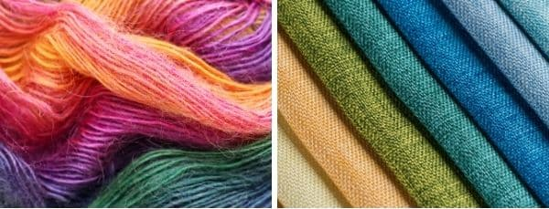
Our purpose and the properties of a fabric together determines which type of fabric can be used for each purpose. Coarse fabrics can be used for mopping and making gunny bags but not for making clothes. Some other properties will have to be considered for choosing curtain fabrics.
History of clothing:
When early people realized they needed more than their own hair and skin to protect them from the weather, they looked around to see what was available. People lived in a cold climate, saw animals with skins that kept them warm. They hunted these animals for food and used the fur to cover their body.
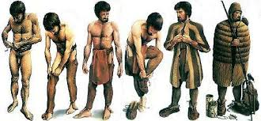
Once they started to hunt, they used the skin of animals to wear as their clothes. This skin when continuously used became harder and made difficult for them to hunt. For this purpose, they started to treat the skin to preserve its softness. Later the bones of animals were used as needle and nerves were used as thread to stitch the hides.
Ancient people used Grasses, reeds, leaves and stems to cover their body of purely the vegetable origin. He also learned to spin the fiber, convert it into yarn and these yarns are interlaced to form a cloth. Flax and wool were the first of the fiber to be used because they were easier to twist into yarn than cotton. They also used the hair of animals as bed, in due course, these hairs tangled with each other and formed as a fabric.
Today, there are many materials with which clothes are made. A person can choose from purchasing clothes made from natural origin materials like silk, wool and leather, but may also select one from the man-made fibers like nylon, polyester etc.
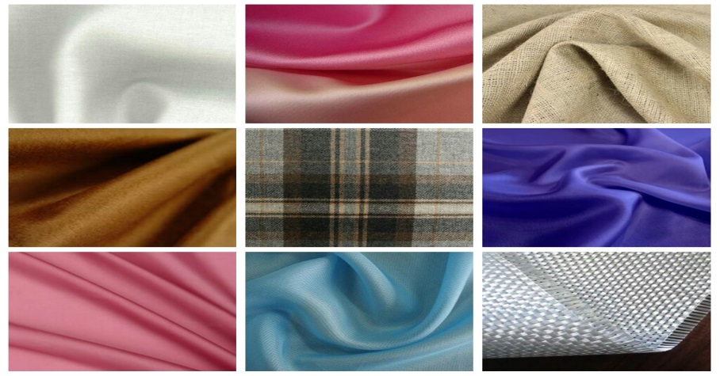
Things made up of fabric:
List things in your house made up of any type of fabric. Which kind of fabric is being used more in your house?
Type of fabric | Things
Cotton | Sari, dresses, shirts, bed sheets etc.
Silk | Sari, kurta etc.
Wool | Sweaters, caps etc.
Polyester | Bags, backpacks, outer wear etc.
Linen | Shirts, sari, kurtas etc.
The material used for making school bags is also a kind of fabric. Fabrics are not only used for making clothes; they are also used in making banners, flags, shoes, curtains, in book binding etc. Calico is a type of fabric used in book binding.
What is a fibre?
A material which is available in the form of thin and continuous strand is called fibre.
Fibres are extremely long, flexible and thin thread-like structures of a natural or artificial substance. Yarn is made from fibres. Furthermore, these yarns are combined to form different types of fabrics.
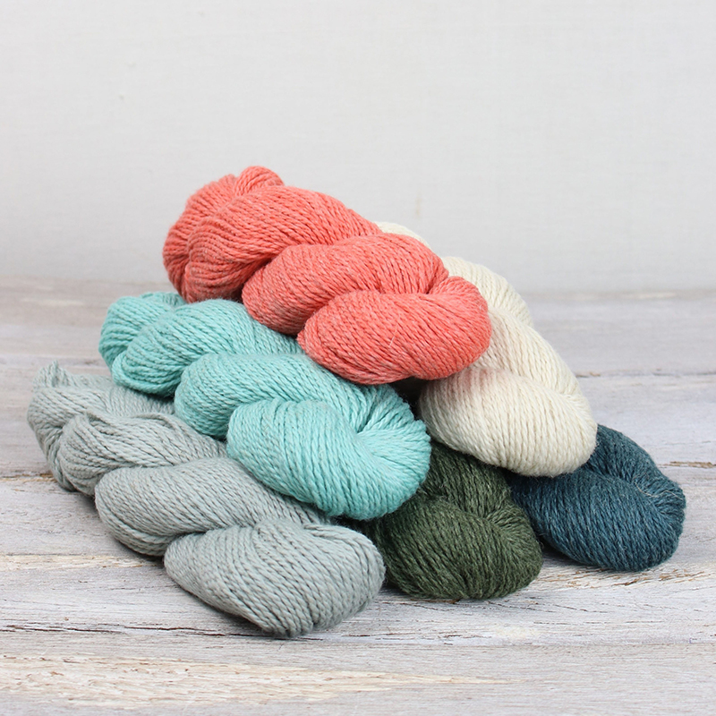
Threads in the fabric:
Take a piece of fabric. With the help of a magnifying lens, observe how the fabric is. Pull out threads one by one from the fabric. Observe these threads.
What did you observe?
Take one thread. Scratch its end. Observe it through a magnifying lens.
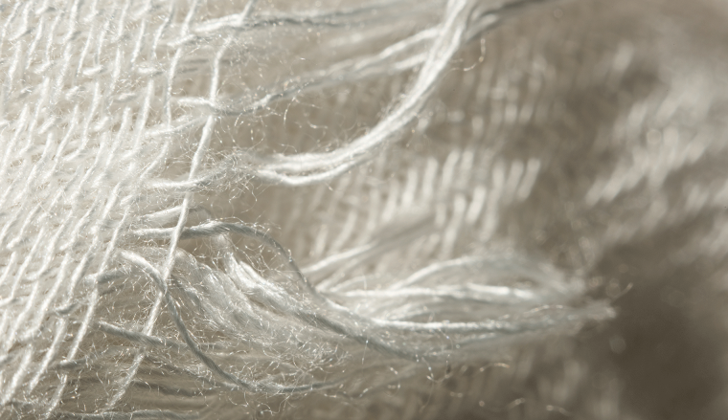
Were you able to see the fine structure of thread?
Take a needle and try to insert this thread into the eye of the needle. Can you? Isn't it difficult? Have you ever seen what people do to overcome this problem? Generally when we are not able to put thread into the eye of the needle, either we twist the end of the thread or we wet the end using saliva.
Fibres are classified into two types based on origin: natural fibres and synthetic fibres.
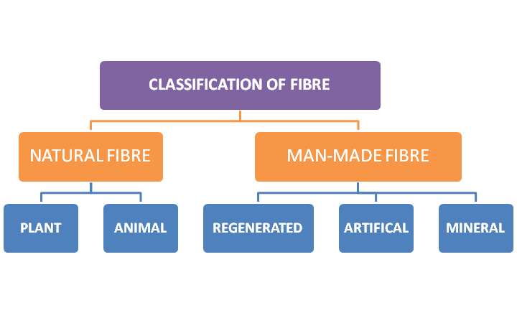
Natural fibers: The fibers which are obtained from plants and animals are called natural fibers.
For example, cotton, wool, and silk are natural fibres which are directly extracted from plants and animals. Cotton and jute are plant fibres. Silk and wool are animal fibres.
Artificial fibres: Nylon, rayon, polyester, etc., are synthetic fibres as they are artificial fibres with several repeating units known as polymers. Synthetic fibres are manufactured in laboratories by various chemical processes.
Characterstics of fabrics:
Collect some natural and artificial fabrics and observe the following characterstics.
S.no | Character | Natural fabric | Artificial fabric
1 | Water absorbing nature | More absorbent | Less absorbent
2 | Time taken to dry | More | Less
3 | Smell while burning | Burn rapidly with yellow flame with smell of burning paper or hair | Shrink away from the flame and burn with an acid, chemical smell
4 | Result after burning | Soft and gray ash | Ash like a plastic bead and not soft
5 | Stretching capacity of yarn | Low | Good stretching capacity
6 | Smoothness | Not much smooth | Very smooth
Silk fabrics are slippery and shiny in nature, whereas cotton fabrics may be coarse as well as smooth. When we burn fabric made up of artificial fibres, it gives a pungent smell. In case of natural fibres, they give a smell like burning paper or hair.
Cotton, wool, silk, jute are all derived from plants and animals. They are called natural fibres. Fibres made of chemicals are called artificial or synthetic fibres.
Tiny strands like structures are called fibres. These fibres are converted into yarn. Yarns are woven together to make a fabric.

