Cotton:
Indians have mainly worn clothing made up of locally grown cotton. India was the one of the first places where cotton was cultivated and used even as early as 2500 BC during the Harappan era.
Approximately 75% of the world’s clothing products contain at least some amount of cotton. Since cotton is highly breathable and absorbent, it is commonly used to make warm-weather clothing. Its softness makes it a good option for formal and business wear, and its notable draping abilities make it an ideal fabric for dresses.
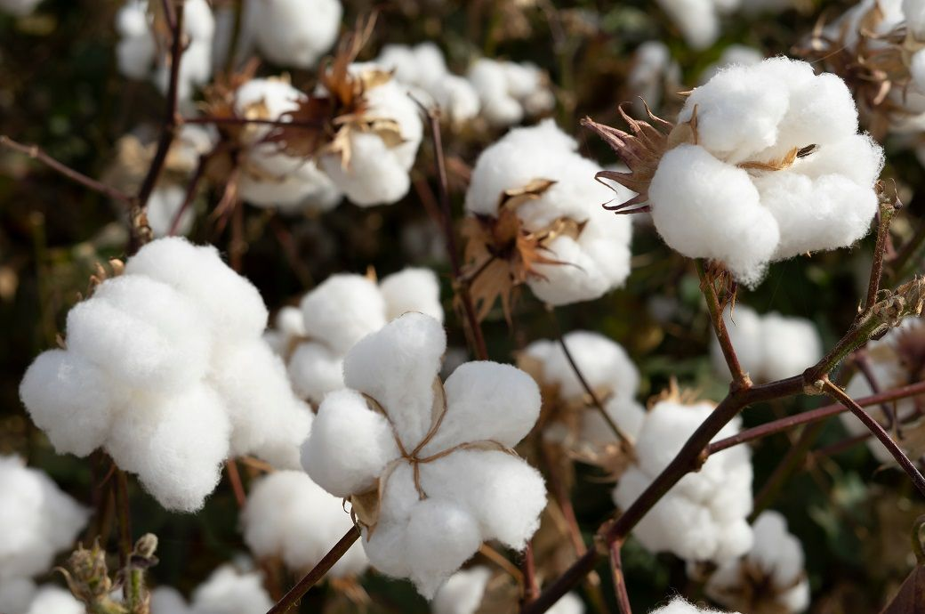
There are six stages in the process of cotton garment manufacture. These include the following: Growing cotton, ginning, cotton spinning, dyeing the cotton fabric, construction of the garment and the final stage of which is the distribution of the garment from the warehouse to the storefront.
Cultivation of Cotton:
The first stage of the process is planting the cotton seed. The seed is then fed by rain and once the cotton plant has grown cotton farmers will then pick the cotton by hand. During the production and growth of cotton, instead of pesticides or chemical fertilizers farmers use a rich compost and remove the pests by hand.
Cotton is cultivated in black clayey soil. It needs warm climate. The sowing of cotton crop is done in early spring. Cotton plants are bushy and about 1-2 meters tall. The plants start flowering in about 60 days and give whitish - yellow flowers. The flowers turn reddish in a few days. Flowers slowly grow into spherical walnut-like structures. These are called cotton balls. Fibres of cotton grow on these seeds.
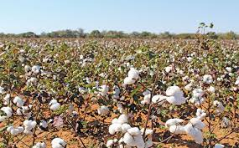
After some time green cotton balls turn brown. At maturity, the cotton balls burst open and the white cotton fibre can be seen.
Ginning:
The cotton picked up from the plants has seeds in it. The process of removing cotton seeds from pods is called ginning. Ginning was traditionally done by hand. Now-a-days, machines are used in ginning.
The cotton ginning process is a generic term used to imply the complete process in effectively turning cotton balls into fibres.
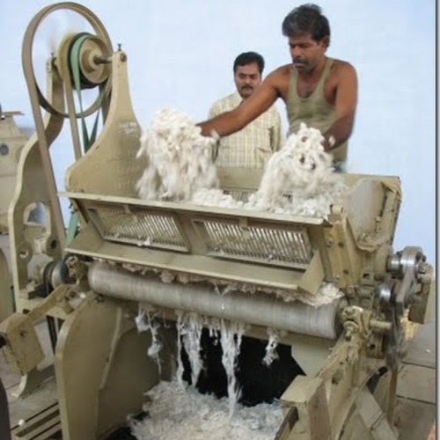
Once the cotton balls are picked, they are then delivered directly to the ginning factory by truck. This is where the cotton is fed into the ginning machine that separates the cotton fibres from the seedpods. This is carried out in order to efficiently remove any dirt, stems, leaves and linters. In the completion of the cleaning and separating stage of the process, the seeds are then later refined to create cottonseed oil, the linters are used in the manufacturing of paper and plastics and the cotton is now referred to as lint cotton as it has been separated from the seed.

Spinning:
The process of making yarn from fibre is called spinning. The raw cotton is supplied to industry in the form of bales.
The cotton spinning process is a term that is used to describe the process in which fibres pass through the carding machine that separates the fibres to become yarn and then eventually be ready to be weaved or knitted.
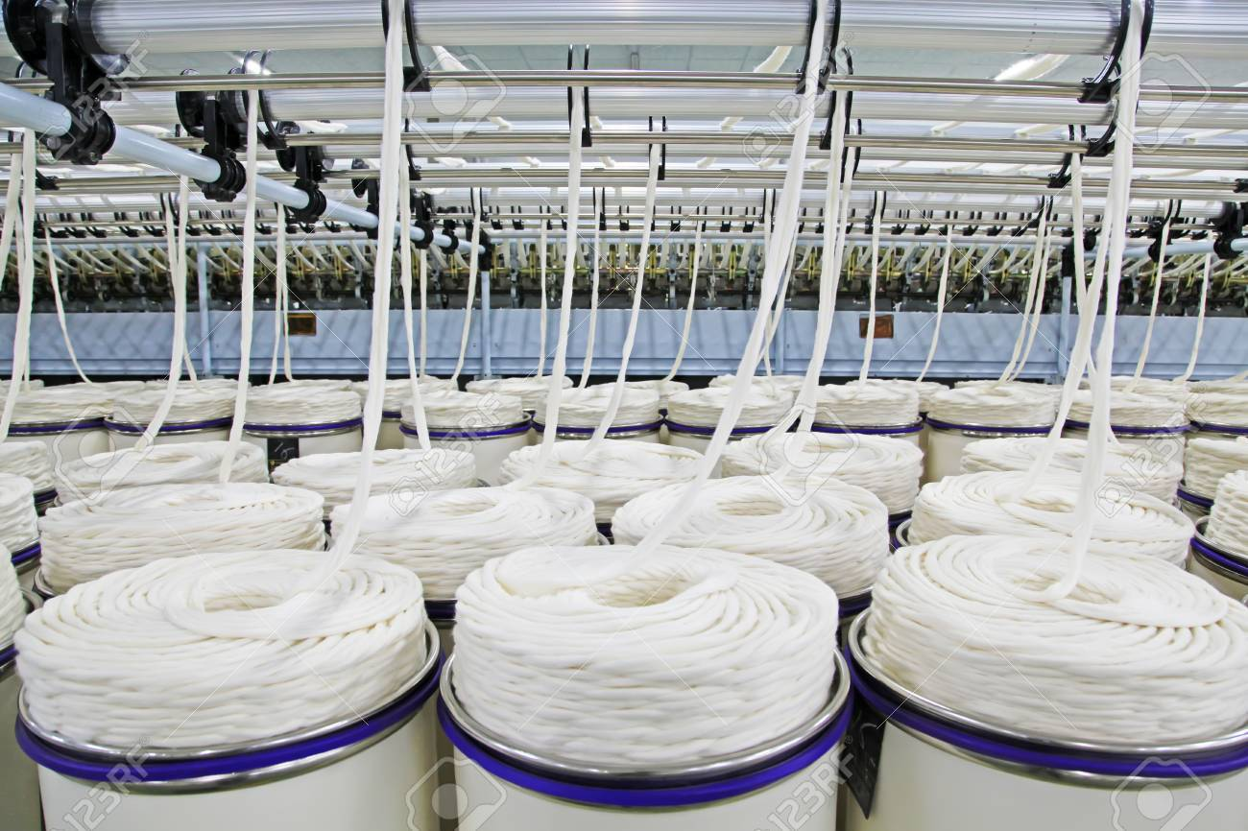
During this process, the cotton is thoroughly cleaned through a rigorous cleaning process. The fibres are then combed by a range of machinery and are finally spun to form soft textured yarn. Once the cotton has been transformed into a knitted cotton fabric it is then put on a truck to be taken to the dyeing factories.
One of the biggest concerns relating to the manufacture of garments is the issue of water waste and toxic chemicals used in the dyeing process.
The conventional dyeing process is a highly toxic process that requires a lot of water. Throughout the dyeing stage, a lot of water waste gets generated and instantly becomes infected with toxic heavy metals and pollutants. The toxic chemicals used in the dyes have a harmful effect on not just the environment but also to the farmers as well as the people living within the surrounding area. This also has a negative impact on consumers as 80% of the toxic chemicals used in these dyes still remain in our clothes long after the production process.
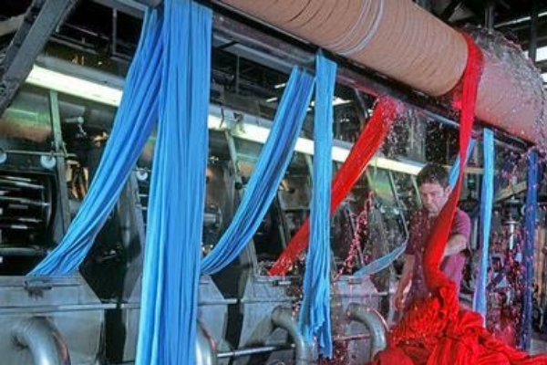
However, in organic certified factories only natural dyes are used. This means that the colors used in the dyes come from elements in nature. Natural dyes require land to grow with ingredients such as indigo, onion shells and turmeric being the most popular of options. The many reasons as to why natural dyes are used less compared to popular synthetic dyes are because natural dyes lack the vibrancy of synthetic dyes. Once the cotton has been dyed it is then sent to the garment factory.

Steps in making cotton yarn:
(a) The raw cotton is loosened and cleaned to remove straw and dried leaves.
(b) The cleaned cotton is then fed into a machine. The cotton fibres are combed, straightened and converted into a rope like structure called sliver.
(c) The sliver of cotton fibre is converted into yarn by spinning using machines.
Weaving:
The process of arranging two sets of yarn together to make a fabric is called weaving. The big reels of yarn are called bobbins. These bobbins are used for weaving the cloth. Cloth is woven on looms. After that they are bleached and dyed to give a finish.
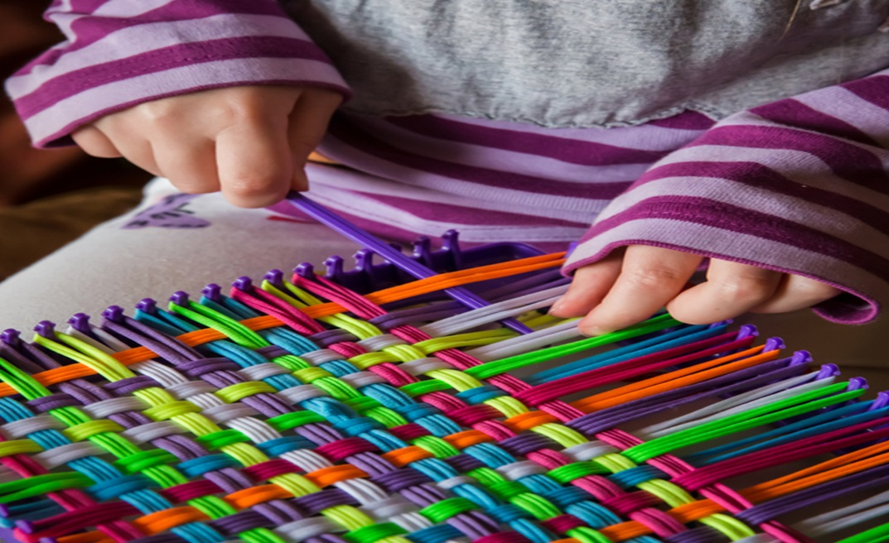

Knitting:
Knitting can be done by hand and machine. Just two yarns are used in knitting, while more than two yarns are used in weaving. Sweater, socks, scarf and caps are knitted from the wool.
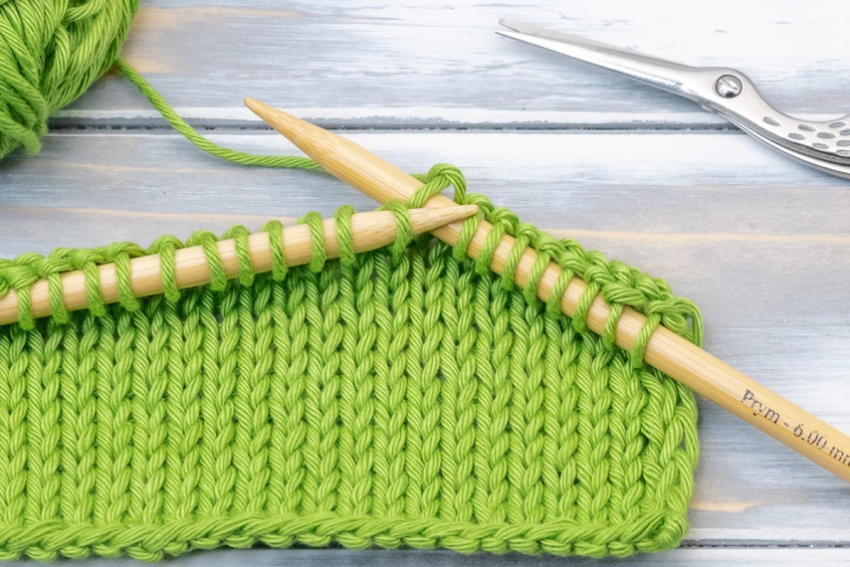
Once the garment is completed they are collected and are then sent for further cleaning and pressing. The garments are then packaged and are stored to be distributed to the warehouse. From the warehouse, the garments are then sent out to stores worldwide for customers to purchase.
Uses of cotton:
Cotton is mostly used for making clothes of various kinds like towels, bed-sheet, curtains, saris etc.
Cotton is the most widely used textile fiber in the world and manufacturers can spin this fabric into a myriad of different types of products. For instance, most T-shirts contain at least some amount of cotton and true blue jeans are 100 percent cotton. This fabric is used to make bathrobes, bathmats and towels and it is also used to make bedsheets, blankets and duvets. Manufacturers may even use cotton to make curtains, wall-hangings and other types of home decorations.
Manufacturers use cotton to make medical supplies and this fabric is also used to make industrial thread and tarps. Cotton can be used to make practically any type of textile for consumer or industry.

