Jute:
Jute fiber is obtained from the stem of the jute plant. It is cultivated in rainy season. Jute is grown in alluvial soil. In India, jute is mainly grown in west Bengal, Bihar and Assam. Jute plants are about 2.5 to 3.5 meter in height. It bears yellow flowers in 3 to 4 months. Jute plants are usually cut at the flowering stage. A good quality fiber is obtained from plants which are cut at the flowering stage.
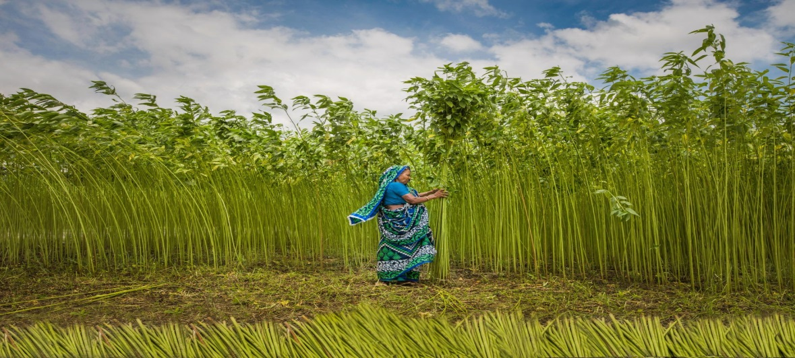
After falling of dry leaves, bundles of dry plants are kept in a pond for a few days. In this period, the gummy skin rots out to separate the fibre. This process is called retting. The jute fiber is obtained from the retted jute by hand.
Jute fibre is pale- yellow in color and 2 to 3 meter long. Jute fibre is very strong and has silky texture. Jute fiber is used mainly for making gunny bags, shopping bags, ropes, carpets, curtains, etc.

What Is Jute Fabric?
Jute fabric is a type of textile fibre made from the jute plant. Cotton takes the title of most-produced plant-based fibre, but jute is a close second. While jute isn’t very popular in the Western world, it is one of the primary textile fibres of India and neighboring countries. Jute plants grow to be over 10 feet high and the fibres derived from these plants are harvested in a single long string. Therefore, jute fibres are among the longest natural textile fibres in the world.
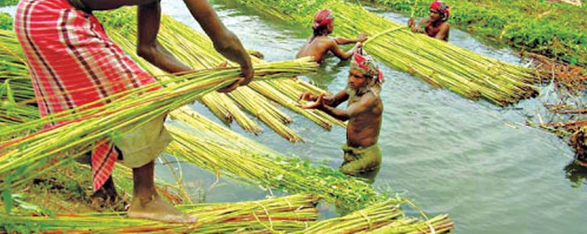
History of Jute:
Jute has been grown for textile purposes on the Indian subcontinent for at least 5,000 years.
Jute is a relatively rough fiber, which means that it isn’t well-suited for apparel applications unless it goes through an extensive production process. Instead, jute’s roughness and durability make it ideal for industrial applications. Most types of jute fabric are loose with woven networks of thick yarn.
While jute absorbs water readily, it also dries quickly, and it is highly resistant to abrasion and stains. Being plant-based, however, jute biodegrades relatively quickly and it isn’t known for its long-term durability in outdoor applications.
The production of jute fabric has remained largely the same for centuries. In most cases, mature jute stalks are harvested by hand and they are then defoliated. Jute fibres can be derived from both the inner stem and the outer skin of the stalk.
A process called retting is used to remove the non-fibrous material from the stem and skin of the jute stalk. Retting softens the stalks and makes it possible to separate the fibrous material from the unusable material by hand.
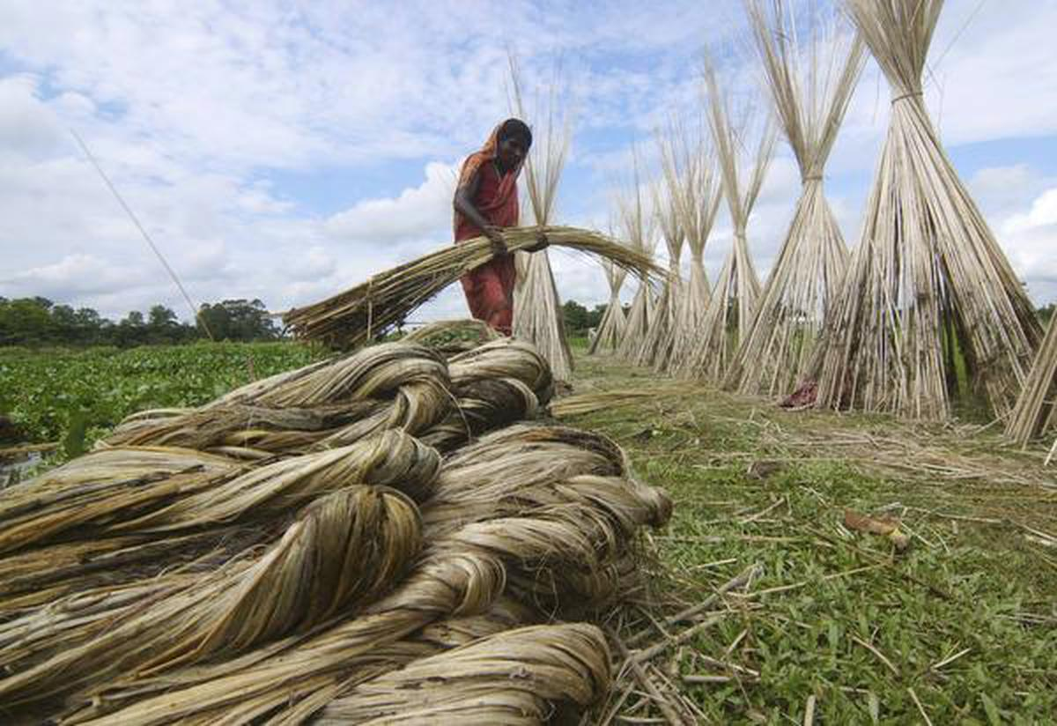
After the jute stalk has been retted, it is possible to separate the long, silky fibres and comb them into long strings. These combed fibres can then be spun into yarn. While it’s technically possible to make jute yarn with automated machines, most jute-producing communities still rely on spinning wheels for this process.
Once jute fibre has been spun into yarn, it may be subjected to a variety of chemical processes to dye it, provide it with water resistance or make it fire-resistant. Then, the finished reels of jute fibre are shipped out to textile production facilities to be woven into apparel or industrial textiles.
In the case of jute apparel, a variety of softening techniques are used to make the finished apparel products more comfortable. Some manufacturers may agitate the jute yarn to reduce its roughness or chemical techniques may be used to achieve the same effect. Jute fiber used for industrial purposes can generally be left in its original condition without using any softening techniques.
Due to its rough texture, jute is not commonly used for apparel production. Recent advancements in jute processing, however, have made it possible to use this traditionally uncomfortable textile for certain types of garments.
Uses of jute:
The traditional uses of jute, however, remain the most popular applications of this fiber. For instance, jute sacks have long been used to transport vegetables, fruits, and other goods.
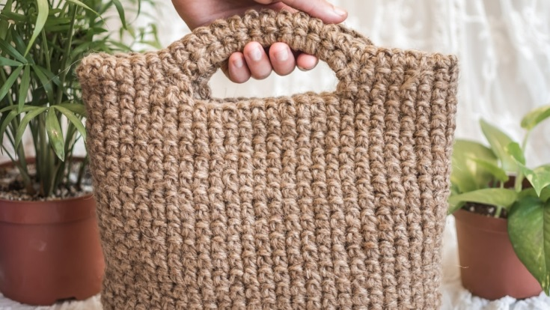
Jute also continues to be used in agricultural applications. This fabric is used to make the protective wrappings around sapling roots when these juvenile trees are transplanted. Since jute is readily biodegradable, saplings can push their roots right through jute fabric bags without encountering any significant resistance.
Basic fibers made from jute are used in a variety of flooring applications. This fiber may also be used to make rugs, carpeting, or other types of fibrous flooring.
Due to its roughness and durability, jute is popular in general homeware applications. For instance, this fabric is popular for upholstery (especially for outdoor furniture), and it is also used to make curtains and canvas. Jute is a major constituent of ghillie suits, which are advanced forms of camouflage that allow military combatants to blend into grassy or otherwise foliage-rich environments.
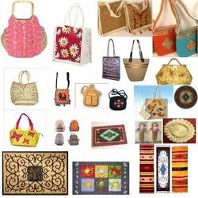
Jute is used in a wide variety of goods. Jute mats and prayer rugs are common in the East, as are jute-backed carpets worldwide. Jute’s single largest use, however, is in sacks and bags, those of finer quality. These bags are used to ship and store grain, fruits and vegetables, flour, sugar, animal feeds, and other agricultural commodities. High-quality jute clothes are the principal fabrics used to provide backing for tufted carpets, as well as for hooked rugs (i.e., Oriental rugs). Jute fibres are also made into twines and rough cordage.

