PLANT PARTS AND FUNCTIONS
A plant is a living organism that produces food for themselves and acts as the primary source of nutrition for all life forms on earth. Plants are also the only source of oxygen in nature.
They are very beneficial to us and give us lot of things. We are surrounded by plants but have you ever stopped to notice the parts of a plant?
- Are all plants similar?
- What are the similarities among them?
Hundreds of thousands of different species or kinds of plant grow on Earth. Some plants are so tiny that people can hardly see them. Others are trees that grow as tall as skyscrapers.
There are variations in the size and shape of plants but generally all plants have roots, stems and leaves.
Most plants have several things in common. They need sunshine, water and air to grow. They are not able to move around. Their cells have stiff walls made of a tough material called cellulose. All green plants use the Sun’s energy, water, and a gas called carbon dioxide to make their own food. This process is called photosynthesis.

PARTS OF A PLANT:
The three basic parts of most plants are the leaf, the stem and the roots. All parts of plants are important and carry out different functions. All of them come together to perform their respective functions for the healthy life of the plant.
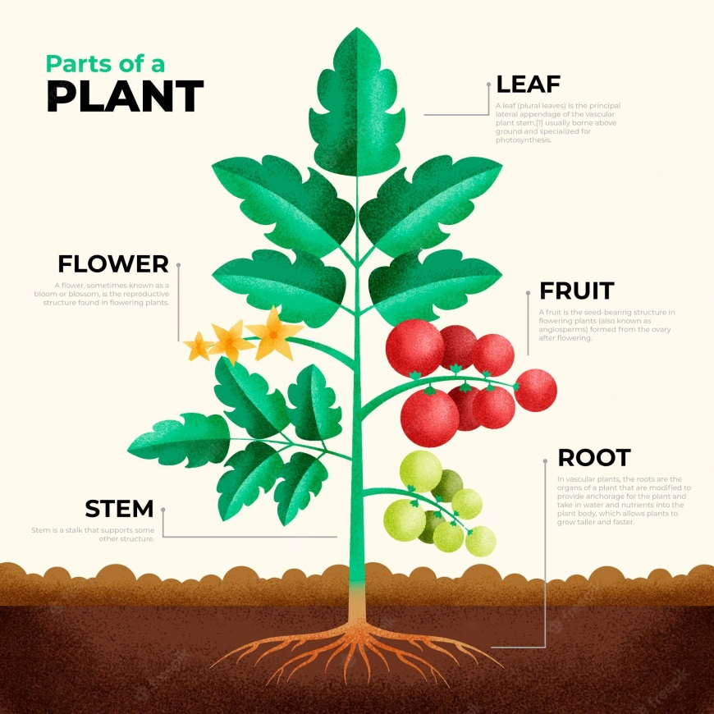
The plants make the environment on this planet. They are an essential part of our lives. There are different parts of plants which have their own feature and functions to do.
The primary parts of the plant are – Roots, Stem and Leaves. They are present in all types of plants.
The secondary parts are – flowers and fruits which are not present in every plant. The parts differ from plant to plant as they all are scattered in different regions and conditions.
- Have you ever thought about the importance of leaf, stem and roots in plants? What is the role of plant parts?
Let us try to understand these things.
Roots:
Roots absorb water and minerals from the soil and hold the plant in the ground so it does not fall over. Roots act like straws absorbing water and minerals from the soil. Tiny root hairs stick out of the root, helping in the absorption. Roots help to anchor the plant in the soil so it does not fall over. Roots also store extra food for future use.
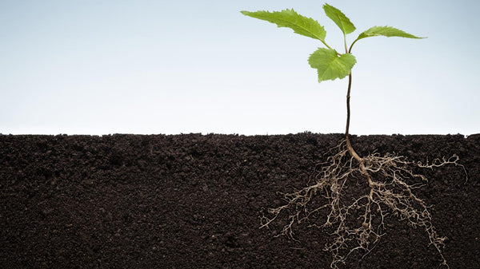
Stem:
The stem is strong and helps hold the plant up. It also lets water and nutrients flow up to the leaves. Stems do many things. They support the plant. They act like the plant's plumbing system, conducting water and nutrients from the roots and food in the form of glucose from the leaves to other plant parts. Stems can be herbaceous like the bendable stem of a daisy or woody like the trunk of an oak tree.
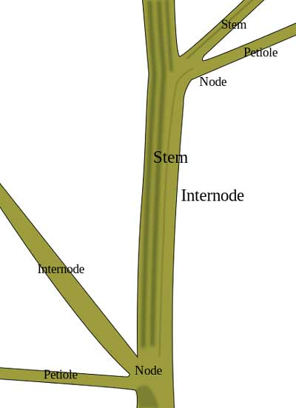
Leaves:
Leaves collect sunlight and make food for the plant. Leaves come in many different shapes and sizes, but most leaves are flat and green. Most plants food is made in their leaves. Leaves are designed to capture sunlight which the plant uses to make food through a process called photosynthesis.
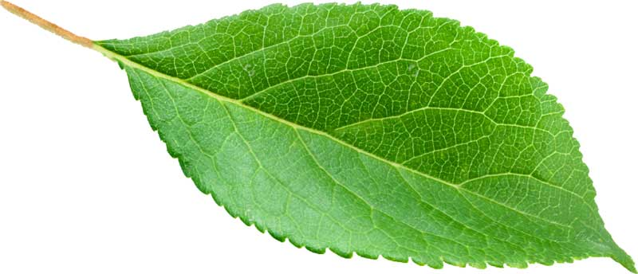
Flowers:
Flowers are the parts of plants that make seeds and fruits. Flowers are colorful so they can attract animals like humming birds and bees. Flowers are the reproductive part of most plants. Flowers contain pollen and tiny eggs called ovules. After pollination of the flower and fertilization of the ovule, the ovule develops into a fruit.
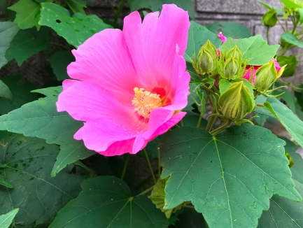
Fruits:
Fruits are the part of plants that protect seeds and helps the seed get moved from place to place by an animal. Animals like to eat fruit because most of them taste sweet. Fruit provides a covering for seeds. Fruit can be fleshy like an apple or hard like a nut.
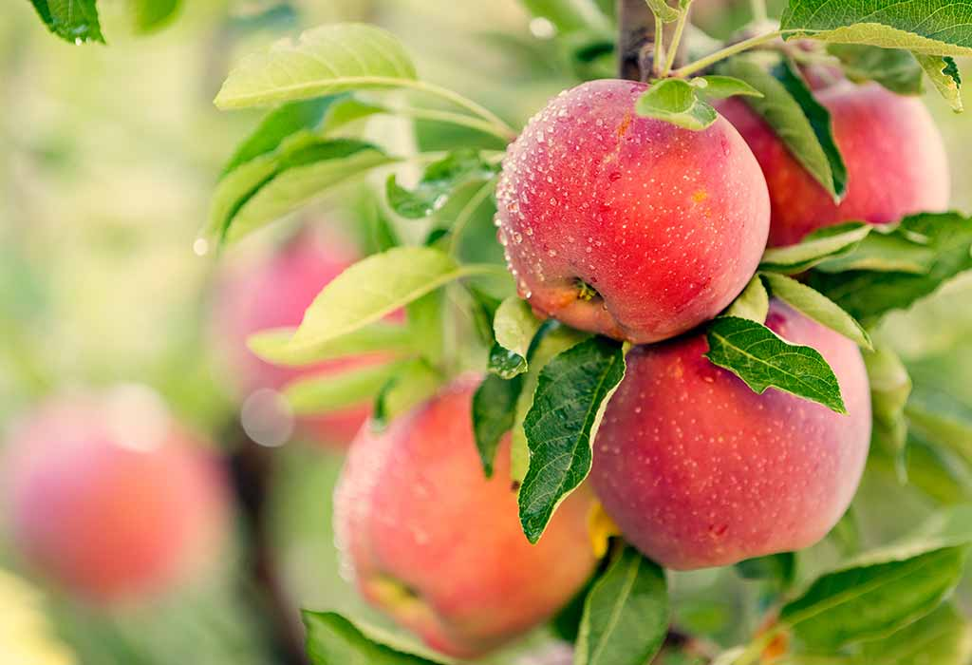
Seeds:
Seeds contain new plants. Seeds form in fruit.
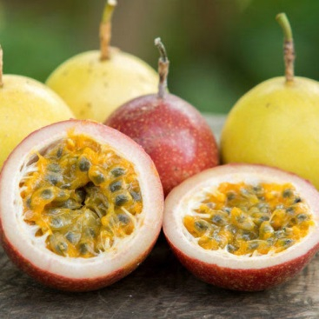
Activity-1: Identification of plant parts
Observe the collected plants and try to identify their parts.
- Did you find any plant which does not have roots?
- Are the leaves of all the plants similar in size?
- Is there any plant without flowers?
- What are the common parts that you observe in all plants?
S.no | Name of the plant | Root | Stem | Leaves | Flower
1 | Brinjal | Yes | Yes | Yes | Yes
2 | Neem | Yes | Yes | Yes | Yes
3 | Mango | Yes | Yes | Yes | Yes
4 | Aloe vera | Yes | Stemless or very short stem | Yes | No
5 | Bonsai | Yes | Yes | Yes | No

There are variations in the size and shape of plants but generally all plants have roots, stems and leaves.

