PARTS OF A PLANT
ROOTS:
Where do we see roots in a plant?
The roots of a plant grow underground. Roots help to keep the plant from falling over and gather water and minerals from the soil. Some plants store food in their roots.
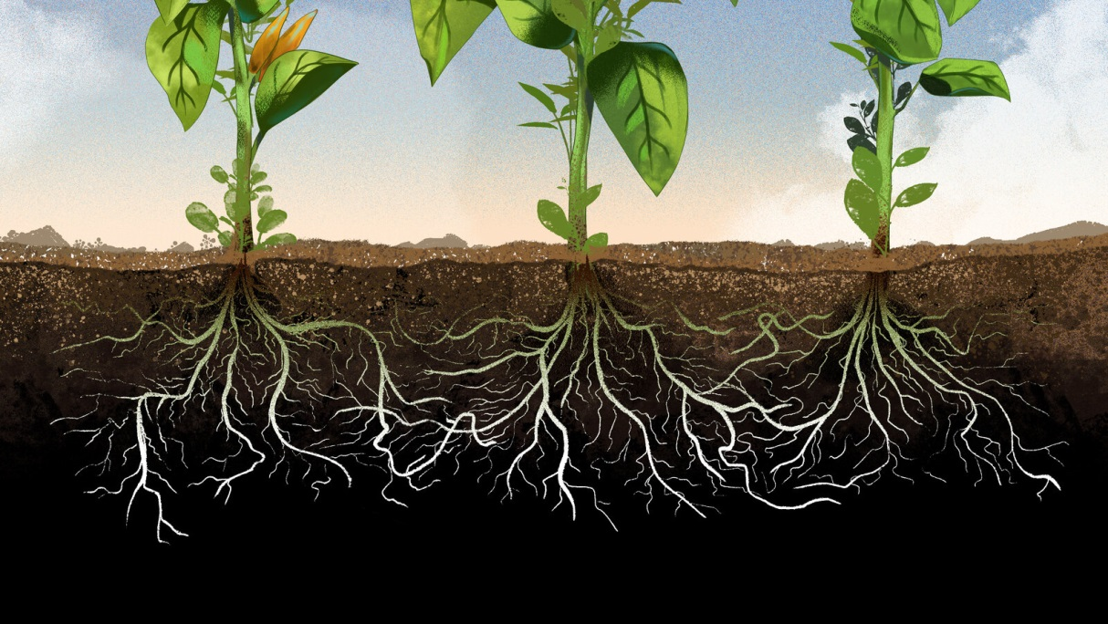
The two major types of roots are fibrous roots and taproots.
- Taproots tend to have one major root that grows very deep. Tap root is a straight tapering root which grows vertically down into soil and gives out branches on all the sides.
Tap root is the main root and the smaller side roots are called lateral roots.

Tap root itself is a quite thick but its branches are much thinner.
Some examples are Pea Plant, Neem tree, Mango tree, Marigold, Tulsi, Gram, Carrot, Radish, Beet and Turnip.
In plants, generally the direct elongation of the radicle leads to the formation of primary root which grows inside the soil. It bears lateral roots of several orders that are referred to as secondary, tertiary roots etc. The primary roots and its branches constitute the tap root system, as seen in the mustard plant.

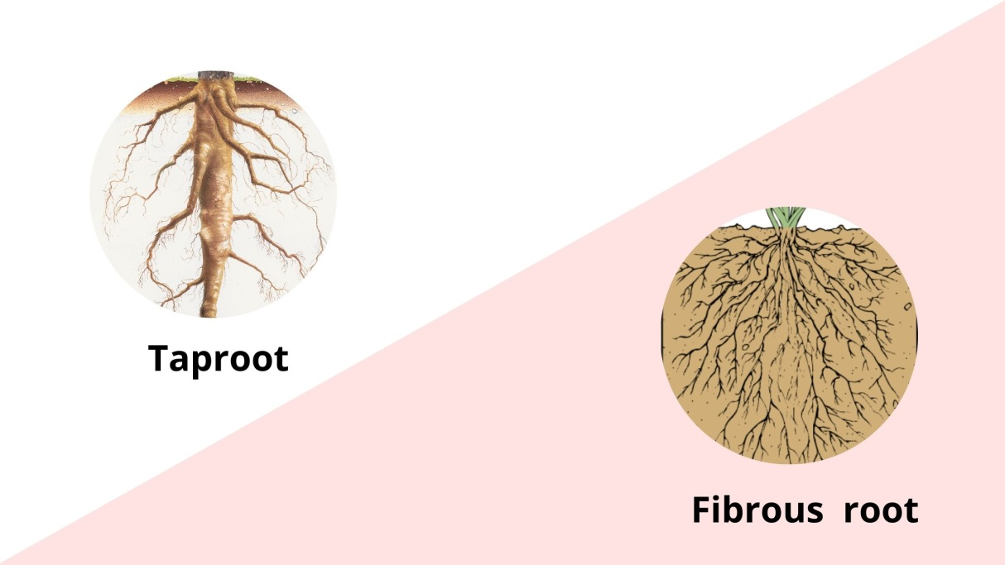
In few plants, the primary root is short lived and is replaced by a large number of roots. These roots originate from the base of the stem and constitute the fibrous root system, as seen in the wheat plant.

The fibrous roots consist of many thin, fibre-like roots of a similar size. Fibrous roots have many roots that grow in all directions. The fibrous roots spread out in the soil and give a firm support to the plant.
Some of the plants which have fibrous roots are Sweet potato, Paddy (rice), Grass, Maize, Millet (Bajra), Sugarcane and Bamboo.
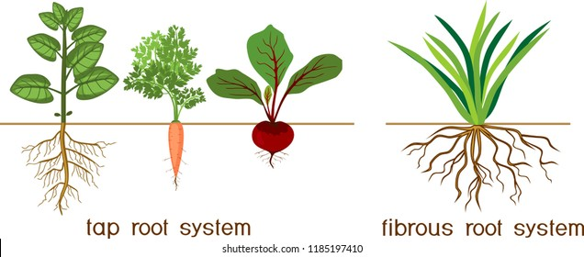
Observe the roots shown in the above picture. How are they? Do all plants have similar types of roots? Is there any difference?
In picture 1 how does the middle root look like? Compare this middle root with the remaining roots of the plant shown in picture 2. Do you find any such main root in plant shown in picture 2? How are the roots of this plant? Do you find any other differences between picture 1 and 2?
In some plants, the main root becomes thick and has thin rootlets. This main root is known as tap root in picture and the rootlets are called lateral roots.
In some plants we find small hair-like roots arising from the base of the stem. This type of root system is known as fibrous root. Here all roots are similar and there is no main root.

In some plants like grass, Monstera and the banyan tree, roots arise from parts of the plant other than the radicle and are called adventitious roots.
The root is covered at the apex by a thimble-like structure called the root cap. It protects the tender apex of the root as it makes its way through the soil.
Tap roots of carrot, turnip and adventitious roots of sweet potato, get swollen and store food.
In some plants such as Rhizophora, growing in swampy areas, many roots come out of the ground and grow vertically upwards. Such roots, called pneumatophores, help to get oxygen for respiration.

Functions of roots:
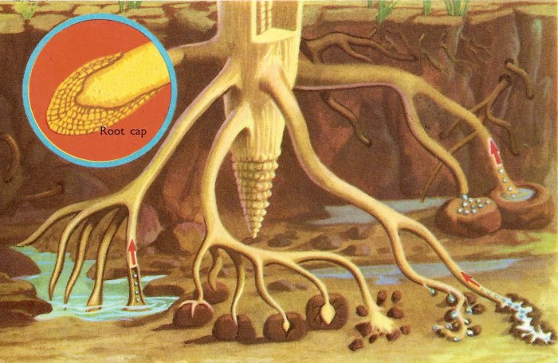
- Roots absorb water and nutrients and along with the stem, provide structural support for the entire plant, anchoring it to the soil.
- Roots absorb water and minerals from the soil and hold the plant in the ground so it does not fall over.
The main functions of the root system are absorption of water and minerals from the soil, providing a proper anchorage to the plant parts, storing reserve food materials and synthesis of plant growth regulators.
Food stored in roots:
The Minerals present in soil get dissolved in the water. The roots absorb water and minerals from the soil and the stem carries them to the leaves. The leaves prepare food. The food prepared in leaves is carried by the stem to all the parts of the plant, which includes roots. Some of the plants store food in their roots. We eat such roots as food. For example radish, carrot, sweet potato, turnip and tapioca which we eat as food are the roots of the respective plants.

