PARTS OF A PLANT
STEM:
The stem is the main structure that supports leaves and flowers. Stems have vascular tissues that move food and water around the plant to help it grow. Plants often store food in their stems.
The stem is strong and helps hold the plant up. It also lets water and nutrients flow up to the leaves.
Stems support the transportation of water, food and nutrients to the entire plant, in addition to playing a role in overall plant support along with the roots.
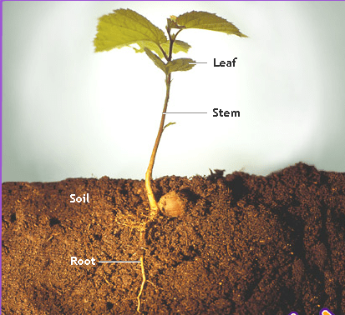
Stems have three main components: xylem, phloem and cambium. The xylem and phloem make up the plants vascular system, which does all of the transporting of water, food and nutrients to the plant. The cambium located between the xylem and phloem is the site of cell division, which means that this is the site of plant growth. When cells divide, the plant actually gets bigger.
The region of the stem where leaves are born are called nodes while internodes are the portions between two nodes.
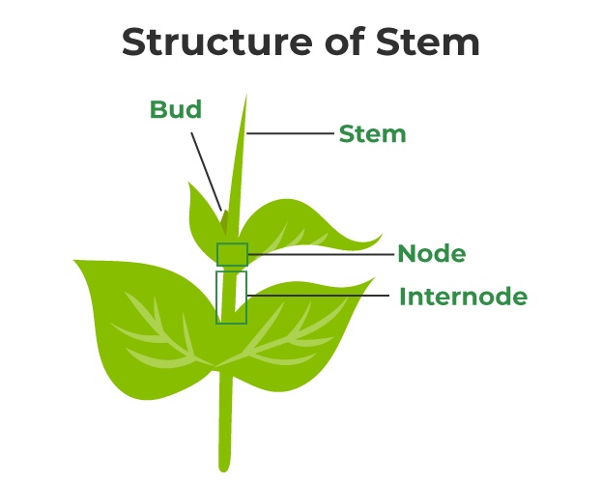
Some stems perform the function of storage of food, support, protection and of vegetative propagation.
Underground stems of potato, ginger and turmeric are modified to store food in them.
Underground stems of some plants such as grass and strawberry, etc., spread to new niches and when older parts die new plants are formed.
Transport of water and minerals in plants:
Plants absorb water and minerals by the roots. The roots have root hair. The root hair increase the surface area of the root for the absorption of water and mineral nutrients dissolved in water. The root hair is in contact with the water present between the soil particles.
Can you guess how water moves from the root to the leaves? What kind of transport system is present in plants?
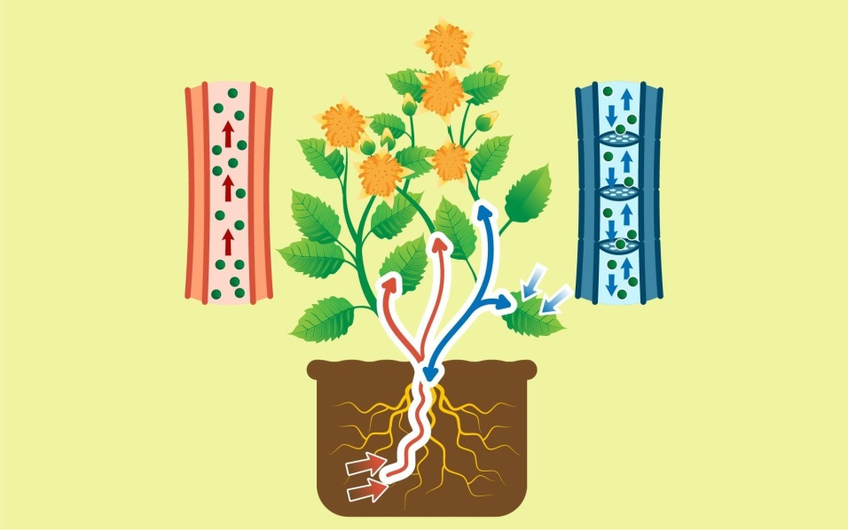
Stems have pipe-like vessels to transport water and nutrients from the soil. The vessels are made of special cells, forming the vascular tissue.
The vascular tissue for the transport of water and nutrients in the plant is called the xylem. The xylem forms a continuous network of channels that connects roots to the leaves through the stem and branches and thus transports water to the entire plant leaves synthesize food.
The food has to be transported to all parts of the plant. This is done by the vascular tissue called the phloem. Thus, xylem and phloem transport substances in plants.

Activity - Absorption of Water:
Take two glass tumblers filled with water. Collect two plants having soft stems, along with their roots.
Add color (red ink) in one of the tumblers. Place the plants in each of the tumbler. Let them be for 2–3 hours and then record your observations.
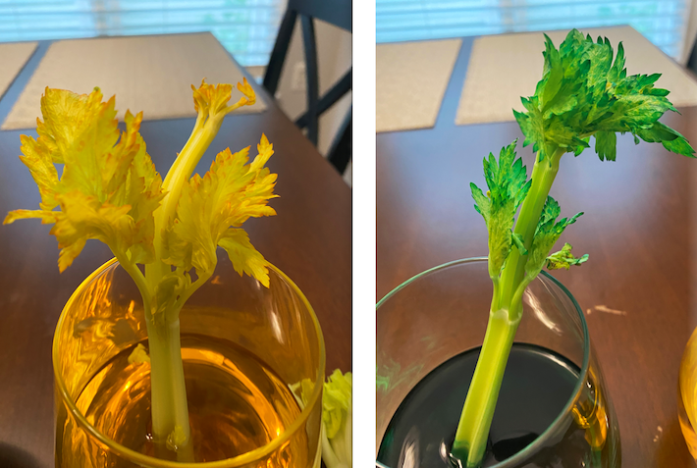
- Why do you think we added red ink in one tumbler?
- Did you see any red spots in the stem or other parts of any of the plants?
- Why did red spots appear on the stem or flower?

We can conclude that roots help in taking up of water from the soil. They do this by absorption. Minerals present in the soil are also absorbed along with the water.

Activity- Carrying food material
Take two small cuttings from a soft stemmed plant. Set them up like you did in previous activity. Wait for 2-3 hours and record your observations.
- What differences did you find between the stem of both the plants?
- Do red spots appear on the leaves or flowers of any of the plants?
Take the stem of a plant which was kept in water with red ink and cut a small section transversely with a sharp blade. Take the help of adult for this. Put it on a slide. Observe it under a microscope.

Do you observe any colored portion?
Now, cut the stem into two halves vertically, from top to bottom. Observe it.

Do you see any colored portion?
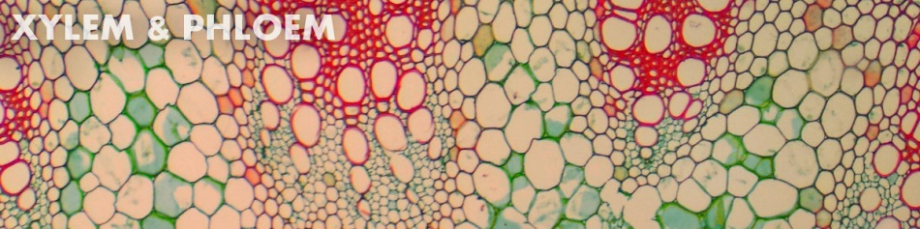
The colored ring like structure that you see act as a tube that carries water and food material throughout the plant. The water absorbed by the root is carried through the stem to all parts of the plant.

