PARTS OF A PLANT
LEAF:
The leaf is an organ of a plant that is specialized for photosynthesis. Leaves capture energy from sunlight as well as collect carbon dioxide from the air. Many leaves are flat and thin in order to catch as much sunlight as possible. However, leaves come in many different shapes including long skinny needles that are found on pine trees.
Leaves collect sunlight and turn that sunlight into food or sugar for the plant. This process is called photosynthesis. Photosynthesis is also the reason our plants are green. Chlorophyll molecules (which give plants their green color) absorb the energy or sunlight used in photosynthesis! Leaves have broad, flat surfaces. This allows for more surface area to be exposed to the sunlight and helps support a high rate of photosynthesis.
Leaves originate from shoot apical meristems. Leaf develops at the node and bears a bud in its axil. The axillary bud later develops into a branch.
A typical leaf consists of three main parts: petiole, lamina and veins.
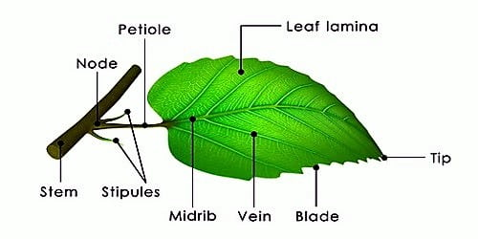
The petiole help hold the blade to light. Long thin flexible petioles allow leaf blades to flutter in wind, thereby cooling the leaf and bringing fresh air to leaf surface.
The lamina or the leaf blade is the green expanded part of the leaf with veins and vein lets. There is, usually, a middle prominent vein, which is known as the midrib.
Veins provide rigidity to the leaf blade and act as channels of transport for water, minerals and food materials.
Leaf Venation:
The arrangement of veins and the vein lets in the lamina of leaf is termed as venation.
When the vein lets form a network, the venation is termed as reticulate. When the veins run parallel to each other within a lamina, the venation is termed as parallel.
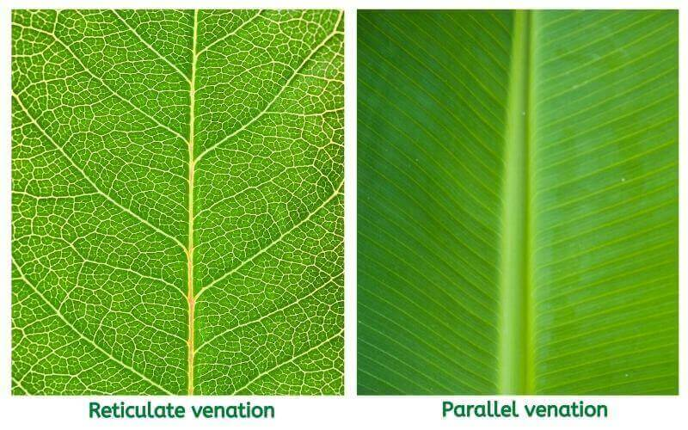
The plants with tap root system have leaves with web-like or reticulate venation and plants with fibrous roots have parallel venation.
Modifications of leaves
Leaves are often modified to perform functions other than photosynthesis. They are converted into tendrils for climbing as in peas or into spines [thorns] for defense as in cacti. The fleshy leaves of onion and garlic store food.
Leaves of certain insectivorous plants such as pitcher plant, Venus-fly trap are also modified leaves.

Transpiration:
Plants absorb mineral nutrients and water from the soil. Not all the water absorbed is utilized by the plant. The water evaporates through the stomata present on the surface of the leaves by the process of transpiration.
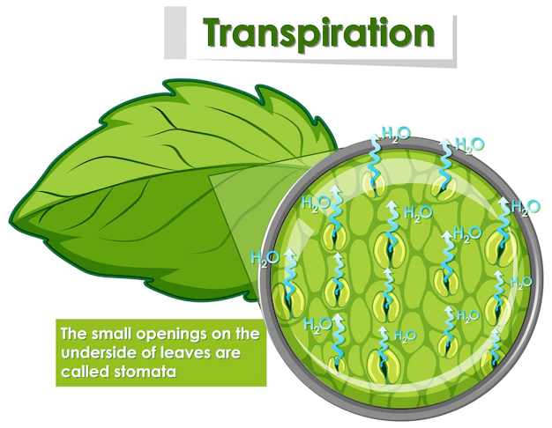

Activity - Stomata Observation:
Take a fleshy leaf. Peel the outer layer of the leaf and place it on a slide. Put a drop of water on it and observe it under a microscope. Try to find some bean shaped parts.
The bean shaped (guard cell) part that you see in the leaf acts like our nose. These are called stomata. It is useful in the exchange of gases between the plant and atmosphere.
The evaporation of water from leaves generates a suction pull (the same that you produce when you suck water through a straw) which can pull water to great heights in the tall trees. Transpiration also cools the plant.
When we place a plant under the fan and the speed of air flow is very high, transpiration will take place through the stomata. Rate of transpiration increases during windy condition.
Increase in the rate of transpiration increases the water absorption also because when transpiration occurs, it will create a transpiration pull and more water absorption will take place.
Activity- Transpiration:
Do you know that excess water is removed in the form of vapors from the leaf surface. To understand this let us do the following activity. Choose a bright, summer day to do the activity.
Select a well-watered plant that has been growing in the sun. Enclose a leafy branch of the plant in a polythene bag and tie up its mouth. Take another polythene bag of same size and tie up its mouth without keeping any plant. Keep both the polythene bags in the sun. After few hours, observe the inner surface of the bags.
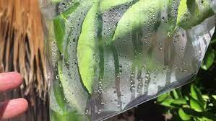
What do you see? Are there any droplets of water in any of the bags?
Which bag has droplets? How do you think they are formed there?
Plants release excess water in their body through stomata and some other parts as well. The water is released in the form of vapor and this process is called transpiration. These vapors condense and are seen as droplets in the polythene bag.
Think, what will happen if transpiration does not take place in plants!
Another leaf function is the preparation of food for the plant by the process of photosynthesis.

