CHANGES AROUND US
Changes occur everywhere and every moment around us. Everything in the world is subject to change. These include the changes from time to time, in the crops growing in the fields, fall of leaves, the growth of fresh leaves on trees, change in the color of the sky, change in color of leaves of trees etc. Flowers bloom and then wither away. Apart from this, we notice some changes in our body like increase in length of nails and hair, increase or decrease in weight and increase in height etc.
There are lot of changes occurring around us. Some of the changes are noticeable while some are not. In fact, everything that exists on the earth undergoes certain changes. These changes are natural as well as man-made. There are many changes happening in our environment like turning of the day into night and vice versa, change of weather, change of season, change of climate, leaves falling from the trees, rusting of an iron etc.
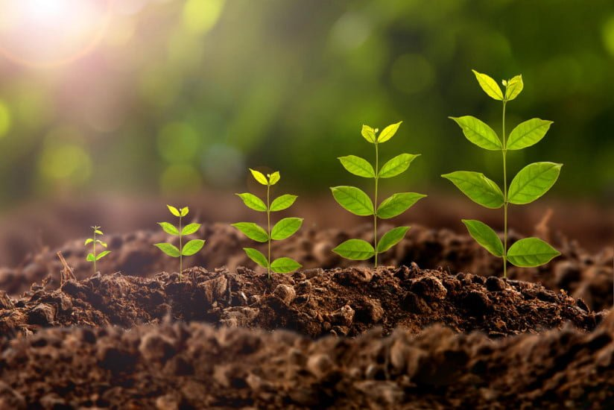
When any substance or object alters one state to another state then it is called a change. During this process, a substance or an object can transform into many kinds. The most common example of change is the growth of humans from a baby to an elder person. There are many other changes like,
- Rising of sun
- Rusting of iron
- Melting of ice
- Elongation of a spring
- Cooking of food
- Germination of seeds
- Folding of a paper
- Growing of plants and
- Frying an egg and many more.
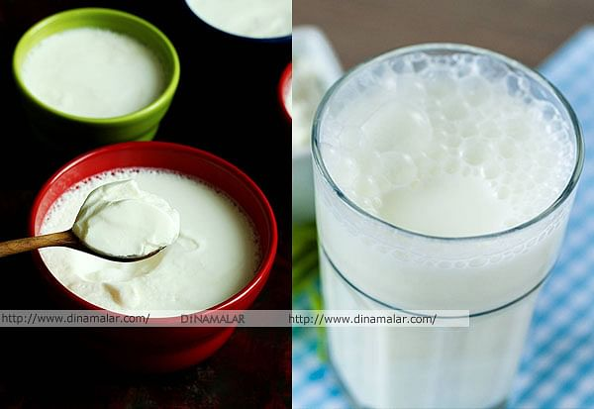
Changing of milk into curd:
We know that curd is prepared from milk. Making curd is our common experience. Curd is prepared in almost every house.
Do you know how milk can be converted into curd?
Generally, curd is prepared by adding a very small quantity of curd (sample curd) to the bowl containing lukewarm milk. Then the bowl containing milk with the sample curd is covered by a lid and kept undisturbed for few hours to get curd.
- What changes do you see when milk is converted into curd? How do you know that milk is changed into curd?
- Is there any change in its state?
- Is there any change in its volume?
- Is there any change in the weight?
Activity-1: Comparing milk and curd
Take some milk in a bowl and some curd in another bowl, compare the color of the milk and curd carefully.
What do you notice?
You may notice that there is slight difference in color from milk to curd. Now take some milk and curd in separate tea spoons and taste them.
Do you find any difference in the taste of milk and curd?
You may notice that milk is somewhat sweet and curd can be slightly or highly sour in taste.
Touch the milk and the curd with your finger to know their state. You will notice that milk is in liquid form. Guess the state of curd. Observe. Curd is neither in solid state nor in liquid state.
What you call this State of material?
The curd is in semisolid form.
From this activity, we find that there are changes in milk when it becomes curd. These include change in the color, taste and in the state. These indicators of change explain that a change has taken place from milk to curd.
Activity-2: Finding the conditions for making curd
Take three equal volumes of empty bowls with lids. Add some ice-cold milk to bowl 1 and same quantity of some warm milk to the bowls- 2 and 3. Then add small quantity of curd to the bowls 1 and 2. Stir them well. The curd must mix in the milk. Cover all the bowls with lids and keep them in your classroom. Leave them and ensure they are not touched even after you have left for home. Observe the changes in the three bowls when you come back to the school next day.
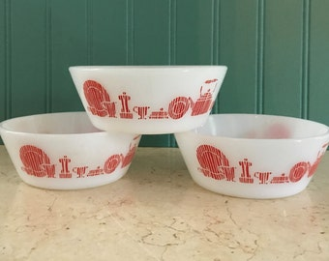
What do you notice about the milk in the three bowls? Has the milk in all the three bowls changed into curd? If not, which has not changed into curd? Compare bowls 1 and 2 and bowls 2 and 3 separately and try to answer the following questions :
- Why do we notice change only in bowl 2, though we added curd to the milk of bowl 1 as well.
- Why do we notice change in bowl-2 though we took warm milk in both bowls 2 and 3?
When we compare the bowls 1 and 2 though the sample curd is added in both bowls, the bowl having warm milk is converted into curd. The cold milk does not change into curd. Similarly, if we compare bowls 2 and 3, though we have taken warm milk in both bowls, only the milk in the bowl 2 to which sample curd has been added changes into curd. We may note that the warm milk in the other bowl does not change into curd. These two observations explain that the reason for change of milk into curd is due to addition of sample curd to warm milk.
The adding of sample curd to the milk helps to grow some kind of bacteria in it and enables conversion of the milk into curd.

