Changing seasons:
Every year we observe that seasons change. We go from rains to winter and winter to summer and so on.
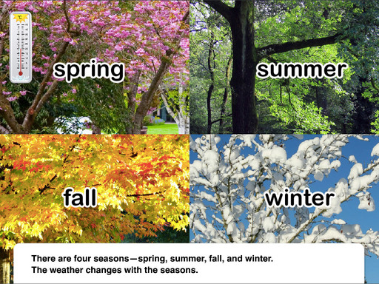
• What changes do you observe from winter season to summer season?
• Is there any change in the clothes we wear?
• Is there any change in coldness and hotness of the air around us?
• Is there any change in duration of day and duration of night? • Is there any change in the food that we eat or drink?
If the winter season changes into summer, we observe change in our clothes. For example, wearing of woolen clothes in winter changes to wearing of cotton clothes in summer. Similarly, we observe that the winter season is cool and summer season is hot. In winter, duration of night is longer than in summer. We take cool drinks in summer but prefer hot tea, coffee or milk in winter. These changes that we observe, show the change of seasons.
Observing the changes in shadow during winter and summer seasons.
Teja likes photographs very much. His father took photos in the months of December and May and are given below.
The picture shows the shadow of a boy, standing on the doorstep of an east facing house, at the time of sunrise. This is on a day in the month of December.
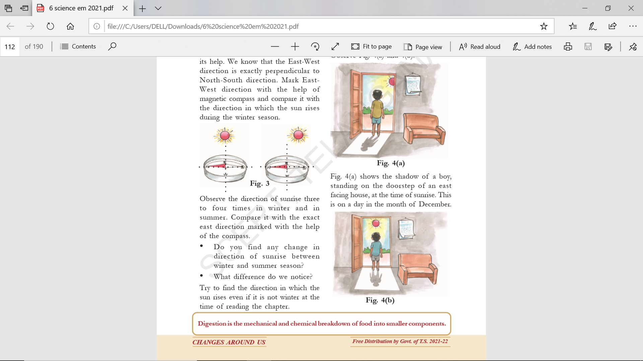
Fig. 4(b) shows the shadow formed at the time of sunrise on a day in the month of May.
• What difference do you notice in length and direction of the two shadows?
• What does it say about the change in the direction of sunrise in December and in May?
You may also ask some elders about the change in the direction of the sun rays coming through windows or doors facing east during winter and summer. You will notice that the sun does not exactly rise in the east. In our State around 20th December, the direction of sunrise is a little south of east. Around 15th May, the direction of sunrise is very close to the east. Because of this, we find that the shadow of the boy is right behind him in May and shifts towards his left in December. This slight change in the direction of the sunrise is one of the reasons for changes in seasons. In the two changes discussed above, we notice that for every change there are indicators to confirm that a change has taken place and there is a cause (reason) of the change.
Compare the change of milk to curd with change of seasons.
• Which change is slow and which is fast? Why?
• Which change takes place naturally?
• Which change needs initiation/ intervention of human beings to occur?
• Which is a temporary change and which is permanent?
If we compare the two changes i.e. the "change from milk to curd" and "change of seasons", we notice that the change of seasons is slow when compared to change of milk to curd. But if we compare change of milk to curd and change in electric bulb due to the switch being on or off, the change of milk to curd is a slow change. Thus, the change of milk to curd is a fast change when compared with change of season but it is a slow change when compared with change in electric bulb being put on or off. Therefore, whether a change is slow or fast is relative.
Similarly, the comparison of above two changes explains that change of seasons takes place naturally, but to change milk into curd we need to add some curd to the warm milk and keep it in such a way that it is not shaken and remains warm. Thus, we need some initiation and intervention from human beings to bring a change in the milk. Also, seasonal changes are temporary as these changes from winter to summer and summer to rains then rains to winter are continuous. Thus, we get winter again.
Change of milk into curd is permanent because we cannot get back milk from curd. The comparison shows that it is possible to classify certain changes as slow or fast, natural or man-made and temporary or permanent.
• Can you think of any other basis for categorization of changes?

s.no | Change | Natural | Man made | Temporary | Permanent | Changes state | Changes shape
1 | Change from milk to curd | No | Yes | No | Yes | Yes | yes
2 | Change in seasons | Yes | No | Yes | No | Yes | No
3 | Change of ice into water and water into ice | Yes | Yes | Yes | No | Yes | Yes
4 | Rusting of iron | Yes | No | No | Yes | Yes | No
5 | Growth in plants | Yes | No | No | Yes | Yes | Yes
6 | Rice to cooked rice | No | Yes | No | Yes | Yes | Yes
7 | Melting of ice cream | No | Yes | No | Yes | Yes | Yes
8 | Egg to boiled egg | No | Yes | No | Yes | Yes | Yes
9 | Electric bulb on and off | No | Yes | Yes | No | Yes | No
10 | Changes in touch me not | Yes | No | Yes | No | Yes | No

