CHANGES AROUND US
Reversible Changes:
When a substance or an object regains its original shape after a change then it is called a reversible change. In reversible change, anybody which undergoes a certain change comes into its original state. There is no formation of new substances takes place in reversible changes. These changes are temporary in nature.
To understand more about the reversible change let us consider an example of a pen spring.
Case 1: In this case, when we can compress the spring, the size of the spring decreases. But, when we stop pushing the spring then it gets back into its original state.
Case 2: Take a spring, stretch it. We all know that we can stretch a spring at a certain limit by pulling it. When we stop pulling the spring then you can see spring immediately get back to its original shape. The size and shape of spring do not change.
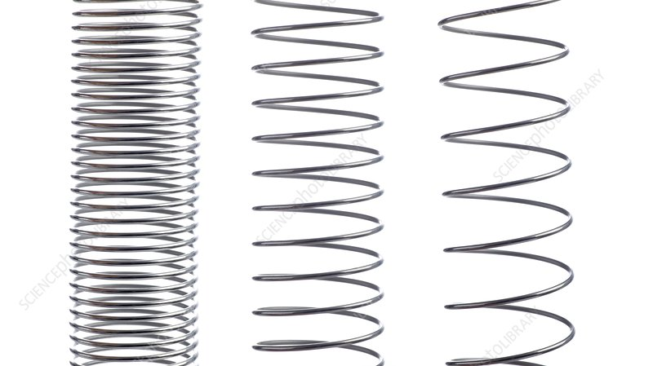
Apart from this, there are some more examples of reversible changes which are shown below:
- Melting of ice
- Inflation of balloon
- Boiling of water
- Folding of a paper
- Stretching of a rubber band
- Knitting a sweater
- Melting of chocolate etc.
Irreversible Changes:
When a substance or an object cannot regain its original shape after a change is known as irreversible change.
In irreversible change, the shape and size of the substance are changed completely. It is impossible to come into its original shape after a change. These changes are permanent in nature. There are some other substances formed after the change takes place in irreversible changes.
Take a candle that has a specific shape and size. When we burn the candle, after some time the candle starts losing its shape. When the candle is fully burned, it is impossible to turn into its original state. So, this change cannot be reversed.
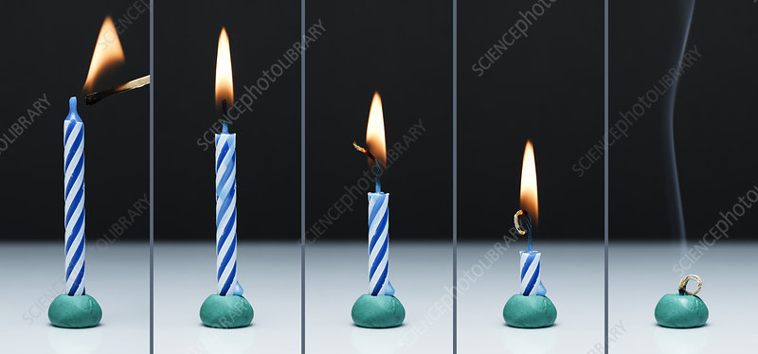
Apart from this, there are some more examples of irreversible changes which are shown below:
- Burning of paper
- Baking a cake
- Rusting of an iron
- Falling of a leaf from tree
- Bursting of a balloon
- Mixing of cement in water
- Dissolving salt in water
- Burning of woods etc.
Physical Changes:
Physical change is defined as a change in which physical appearance such as shape, size, state, texture etc. of a substance or an object is changed. There is no chemical reaction takes place during the physical change. The physical properties of the substance change while chemical properties remain the same. There is no formation of a new substance, only the physical appearance of the substance changes. In physical changes, most of the changes are reversible in nature i.e. temporary.
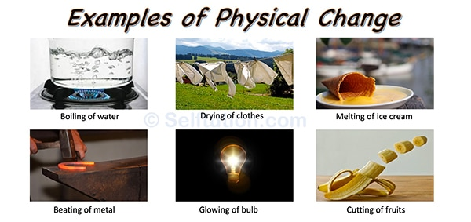
There are some real life examples of physical changes which are mentioned below:
- Melting of an ice cube
- Boiling of water
- Carbon changing from graphite into a diamond
- Shredding of paper
- Breaking a glass etc.
Chemical Changes:
Chemical change is defined as a change in the chemical properties of the substance.
During the chemical change, physical properties of the substance do not change. Only the chemical composition of the substance changes which forms the new substance. There is a formation of new substance takes place after a chemical change. Most of the chemical changes are irreversible i.e. permanent.
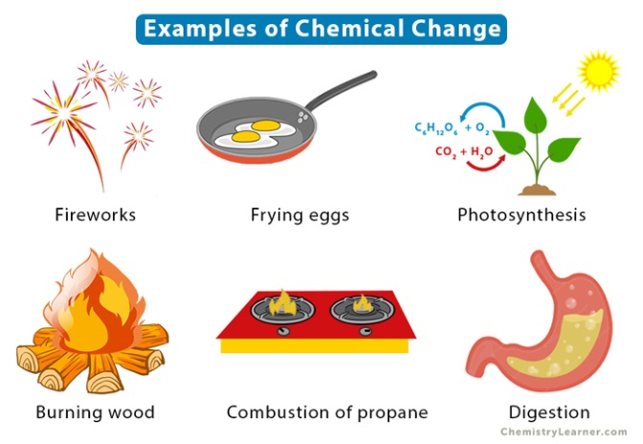
There are some real-life examples of chemical changes which are mentioned below:
- Baking a cake
- Frying an egg
- Rusting of an iron
- Burning of wood
- Digestion of food
- Mixing acid and base etc.
Slow Changes:
Slow change is defined as a change which takes long time to complete. These changes do not happen immediately, it takes a lot of time to complete its process.
There are some most common examples of slow changes which are shown below:
- Rusting of iron
- Photosynthesis process
- Digestion of food
- Weathering
- Erosion
- Deposition
- Growth of living organisms etc.
Fast Changes
Fast change is defined as the change which happens very quickly i.e. takes less time to occur. There are some most common examples of fast changes which are shown below:
- Melting of ice
- Bursting of crackers
- Volcanic eruptions
- Earthquakes
- Land sliding
- Burning of paper etc.
Periodic Changes:
Periodic change is defined as the change which happens after a regular period of time. Periodic changes repeat themselves after a particular period of time.
Examples:
- Swinging of a pendulum
- Change of season
- Change in the phases of the moon
- Beating of heart
- Day and night cycle.

Non-Periodic Changes
Non-Periodic changes are defined as the changes which do not occur at regular intervals of time. Non-periodic changes do not repeat after a particular time period.
Examples:
- Eruptions of volcanoes
- Forest fires
- Earthquakes
- Rusting of an iron
- Accidents etc.
There will be many indicators of changes to show that a change took place. Classification of changes is also made based on various indicators of change like the change in state, change in color, change in size, change in taste etc. There exists a cause for every change.

