WATER IN OUR LIFE
SOURCES OF WATER:
Water plays a vital role in the planet Earth. Water is the driving force of all the living organisms on the Earth.
Water is an essential natural resource. Water is a wonderful liquid. It is one of the most common substances around us. There is water almost everywhere on the earth. About three-fourths of the earth’s surface is covered with water. Water is also present inside us. All living things need water to survive. A person can survive longer without food than without water to drink.
What are the sources of water?
- Surface water - The water that is found on the surface of the earth is called surface water. For example, water obtained from reservoirs, rivers, streams, ponds, lakes, etc. is called surface water, which we get from the surface of the earth.
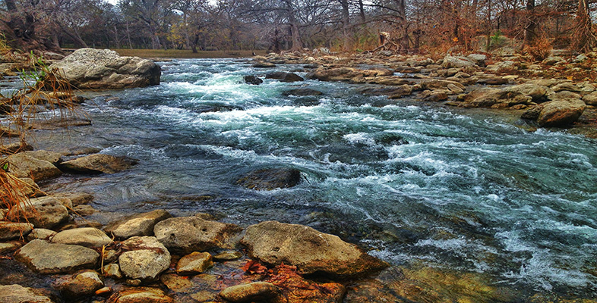
Surface water is present on the surface of the earth. It is of the following types:
(a) River and Lake Water
The water in rivers and lakes comes from rain and the melting of snow on the mountains. Water flows down the mountains and goes into rivers. On its way, it dissolves some soluble salts and carries suspended impurities. It contains harmful materials that are discharged into rivers by factories and also sewage from our cities.
(b) Seawater
Streams and rivers finally flow into the sea. Seawater contains the dissolved presence of a large amount of common salt. Seawater is salty in taste and is called saline water. It is unfit for drinking, agricultural or industrial needs.

- Rainwater - The water that we get through rain and we collect that water and use it for our needs is called rainwater.
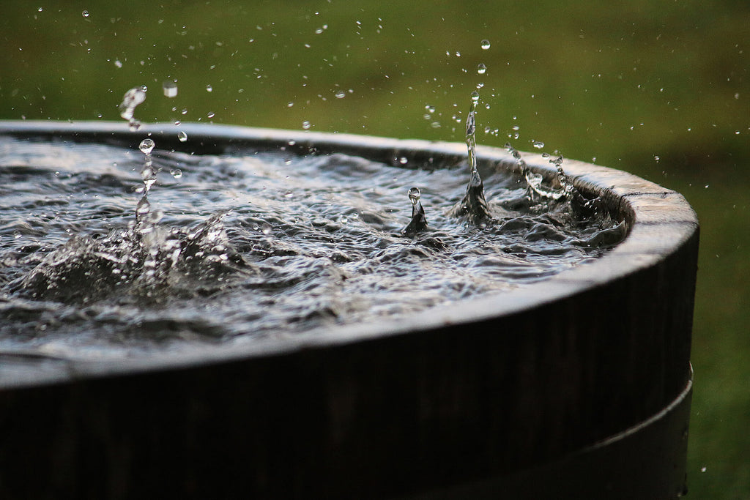
Rainwater is the purest form of natural water because it is usually free from any impurity. But the first shower, while coming down to earth, collects dust particles, germs and bacteria from the atmosphere. So, they contain most of the impurities.
3. Underground Water or Subsoil Water
Some of the rainwater that falls on the earth seeps through the soil and goes down the surface of the earth. Ultimately, this water is stopped by some hard-non-porous rocks and collects there. The water present below the earth’s surface is called groundwater or underground water. The level of groundwater is called the water table.
The water that is found below the surface of the earth between rocks and soils is called groundwater. You can get this water through wells, tube wells, and hand pumps.
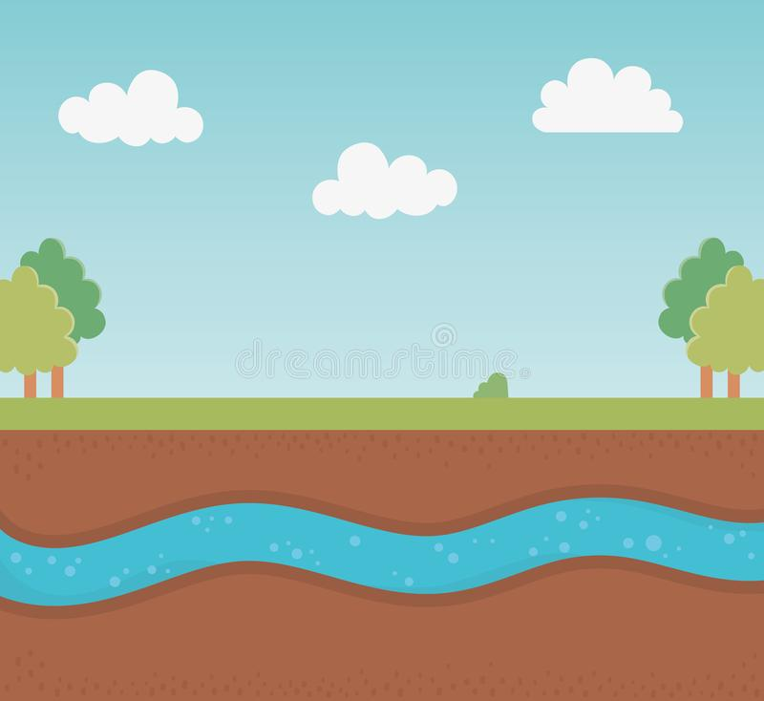
Groundwater is pumped out by digging wells deep enough to reach the water table. Hand-pumps or tube wells are also used to pump out groundwater. This groundwater is used for household, agricultural and industrial purposes.
How the well was dug?
Go to nearby village and look at a well from where people get drinking water.
Can you estimate the approximate volume of water in the well?
Collect information from elders in the village about the level of water in the well over the years.
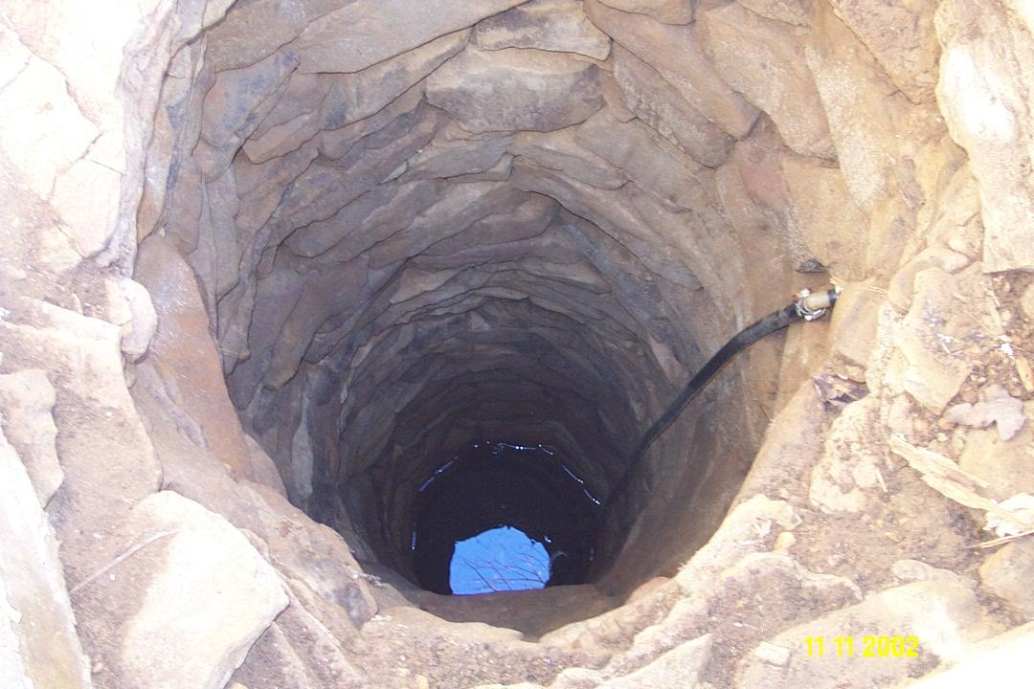
• Is the water level constant or has it changed?
• How was the well dug?
• Have you seen a borewell being dug?
Historically, a dug well was excavated below the groundwater table until incoming water exceeded the digger's bailing rate. The well was then lined (cased) with stones, brick, tile, or other material to prevent collapse.
Tapping of ground water by digging a well or borewell is a tough job. Many people put in a lot of hard work in this process. We need to appreciate this and preserve water.
At some places, water comes out from the ground in the form of springs due to high pressure inside. It is called spring water. The water of springs and wells is filtered through different layers of soil. So, there are no suspended impurities in it.
The main source of water in our surroundings is the rivers. They supply water for various purposes. Rivers flow down from the mountains.
We also get water from lakes, ponds, streams, etc. These are the natural sources of water.
Borewells, dams and canals are man-made sources of water.
During the rainy season, the rainwater seeps through the soil and is stored in the underground water table. We can use this water by digging wells.
Major part of our earth is covered by water, but they are either glaciers or oceans and seawater. We cannot use such water for our daily activities.
How Do We Get Potable Water?
Do we drink water directly from the river or pond?
No! We usually get the water supply through closed pipelines.
Water from rivers, dams, lakes, etc., goes to purification plants.
From the purification plants, water is distributed to the houses through the municipality.
Once it reaches our house, we store it in tanks and containers like bottles, pots, buckets, etc.

