MOVEMENT OF ANIMALS
Without the ability to move, there would be no life on Earth. Moving around is essential to many animals for finding food and a mate. Even plants move, by spreading themselves with the help of seeds or sprouts.
But how is moving around possible? What kinds of adaptations do different kinds of animals in different environments have, and how do they help them survive?
WHERE AND HOW DOES MOVING AROUND TAKE PLACE?
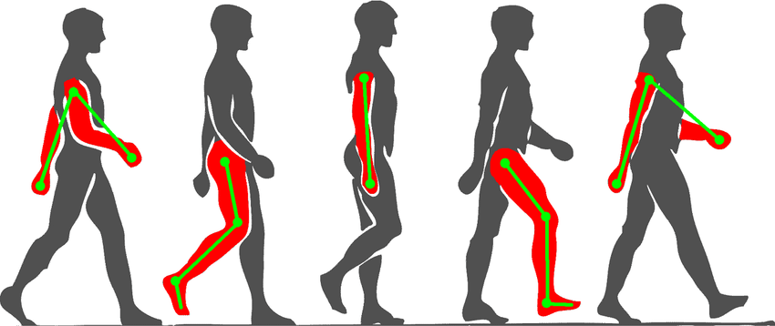
For moving around, animals have occupied almost all places that are suitable for life: the underground soil, the surface of the ground, water and air. The varied nature of moving is indicated even by the words that we use for describing different sorts of movement: crawling, digging, walking, running, climbing, jumping, flying, jogging, dashing, sneaking, floating, gliding, and so on. By movement, we usually mean displacement from one place to another. But an animal can also simply move its body or limbs – that is, change their position. Moving the body is the foundation of moving about. Even when birds lets air currents carry them, they in fact change the position of their wings and tail, thereby changing the direction where they are travelling.
There are a variety of movements which happen in the human body, for example, the movement of eyelids, heart muscles, jaw and teeth. Further, movement of arms and legs, head as well as neck are also counted. Interestingly, movement of some organs occurs because of the collaboration of muscles and bones.
Anatomy of Human Beings
Before delving deeper into the human body and its movements, we should know about the present anatomy of humans.
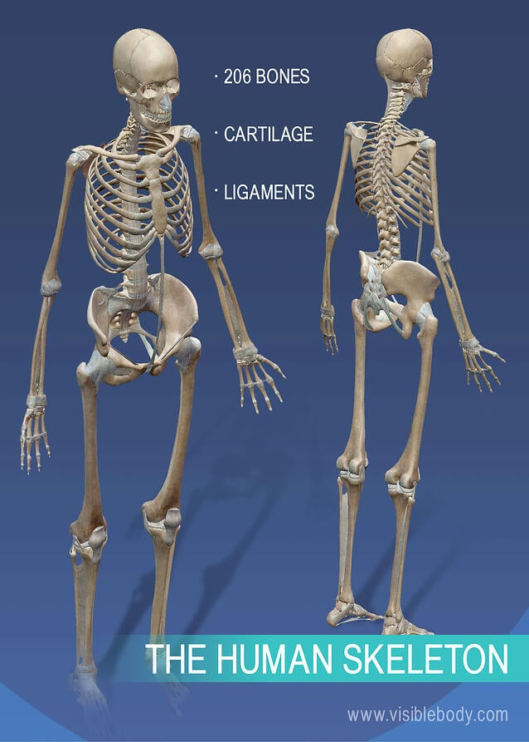

Number of Bones
During birth, a baby has as much as 305 bones in his or her body. With years of growth in becoming an adult, an individual loses a few of them to come down to a total of 206 bones.
Body Shape
Bones are joined to one another in various ways called joints. For example, elbow, knee, ankle, etc. All of these are flexible and provide shape to the body.
Body Structure
The skeleton is formed as a result of multiple joints and cartilages. A collection of bones provides a specific structure to a body irrespective of the outer muscle covering.
Skull
Skull protects our brain and is formed by several bones being joined together.
Muscles:
The outer covering of flesh present over the skeletal structure is called muscle. These muscles function to facilitate movement in a bone. These can be relaxed and contracted, based on the specific action and its need.
If you observe a cow, bull or horse, walking or running, you can see some fleshy structures moving beneath their skin, usually around the shoulders and hips. These tender fleshy structures are called muscles.
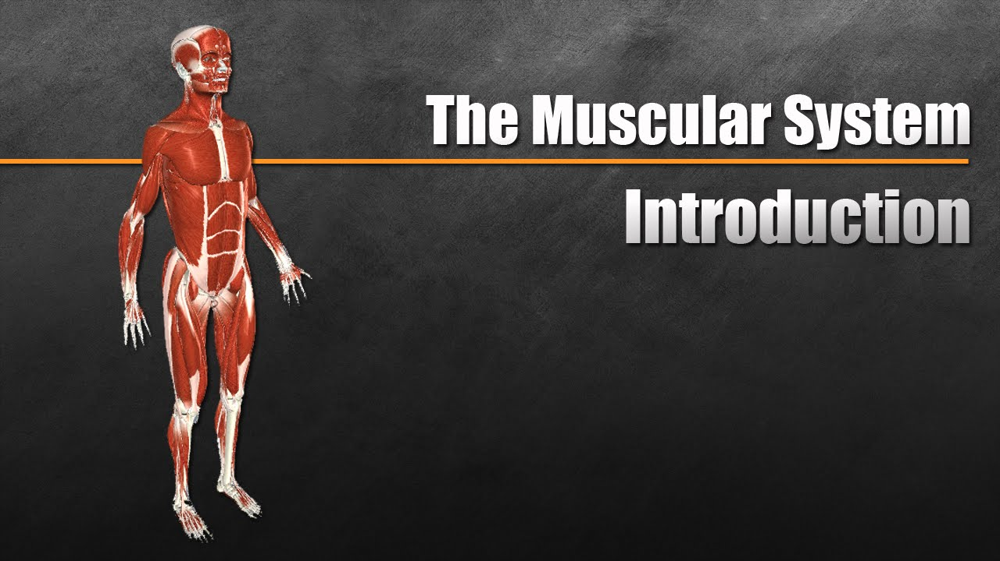
How do Muscles work?
Muscles work in pairs. When one of them contracts, the bone is pulled in that direction and the other muscle of the pair relaxes. To move the bone in the opposite direction, the relaxed muscle contracts and the first one relaxes. Thus two muscles have to work together to move a bone.
Are the muscles attached to bones?
Some muscles are connected directly to bones.
Do you know? Almost all our body movements depend on muscles, bones and joints. Expansion and contraction of muscle makes the bone move. Muscles always work in pairs.
Some muscles have round, white, rope-like fibres at their ends that connect them to the bone. These fibrous structures are called tendons. You can feel the tendons in several parts of your body like; for example, above the elbow, beneath the knee, near the ankle.

