MOVEMENT IN ANIMALS
Bones:
The different bones of different body parts combine together to form a single structure or system. This structure is called the skeleton. It is very interesting to study the skeletal system, and it is funny to think, how we are with our skeleton.
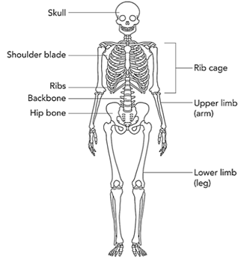
The human skeleton has a number of functions, such as protection and supporting weight. Different types of bones have differing shapes related to their particular function.
So, what are the different types of bones?

1. Flat Bones Protect Internal Organs
There are flat bones in the skull, rib cage and pelvis regions. The function of flat bones is to protect internal organs such as the brain, heart, and pelvic organs. They can provide 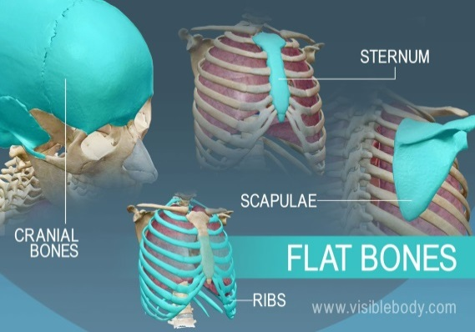 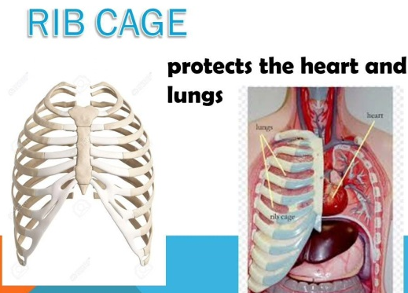
protection, like a shield and also provide large areas of attachment for muscles.

2. Long Bones Support Weight and Facilitate Movement
The long bones, longer than they are wide, include the femur (the longest bone in the body) as well as relatively small bones in the fingers. Long bones function to support the weight of the body and facilitate movement.
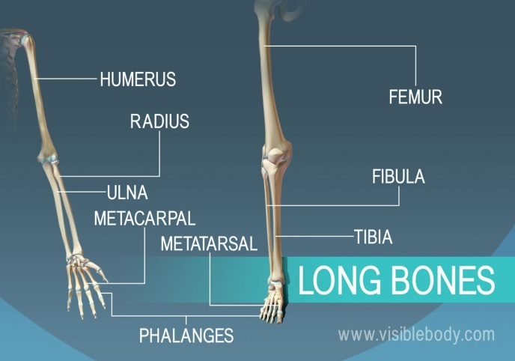

3. Short Bones Are Cube-shaped
Short bones are about as long as they are wide. Located in the wrist and ankle joints, short bones provide stability and some movement.
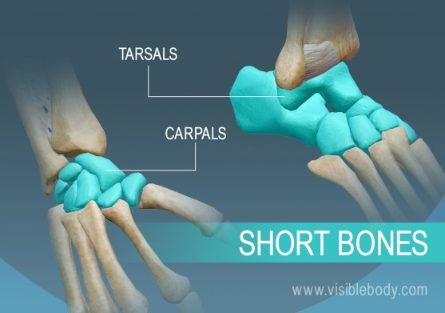

4. Irregular Bones Have Complex Shapes
Irregular bones vary in shape and structure and therefore do not fit into any other category. For example, the vertebrae, irregular bones of the vertebral column, protect the spinal cord. The irregular bones of the pelvis (pubis, ilium, and ischium) protect organs in the pelvic cavity.
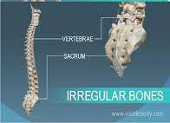
You saw earlier that muscles are joined to the bones to help them move. In the same way, two bones are joined together in a special way by fibres. These fibres are called ligaments.
We knew that muscles help move a bone. How does one bone help the other to move? Put a meter scale under your arm so that your elbow is in the centre. Ask your friend to tie the scale and your arm together. Now try to bend your elbow. Is it possible?
Bones can't bend. You have seen that the human skeleton is made up of many bones. What will happen if bones can’t move? Bones of our body move in their own way, How is it possible? These bones have joints between them. We can move various parts of our body because of these joints.
There are different types of joints in our body to help us carry out different movements and activities.
Joints
For any organism including humans, the point of meeting for two or more bones is called as a joint. For example, ligaments connect a bone to another bone; whereas, tendons hold a bone to a muscle. These joints provide us flexibility to move in different directions as well. Here are the types of joints:
Fixed Joints: These are the joints along which no bone movement are possible. These are immovable joints found in the skull. They do not allow any kind of movement and only provide a definite shape.
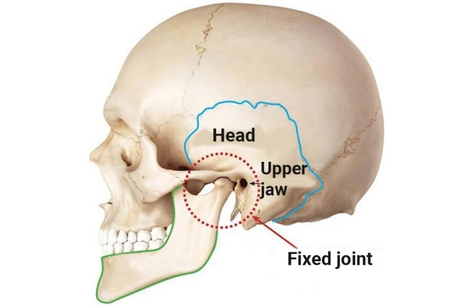
For example, joints present in the skull bone or cranium are known as immovable joints or linkages.
Some joints between bones in our head can't move; such joints are called fixed joints. These joints are fused and seem to be a single bone in the skull. When you open your mouth, you can move your lower jaw. Can you move the upper jaw as well? There is a joint between the upper jaw and the rest of the head. It is a fixed joint. So you cannot move the upper jaw.
Moveable Joints: The two versions of movable joints are freely movable joints and partially movable joints. Further, there are in total four types of movable joints present in our body.
Pivot Joint: These joint types allow movement across different planes, that is, up and down, as well as side-to-side actions. You can check that, the joint between your skull and the vertebral column is a pivot joint.
The head and neck are joined together with this joint. This helps in movement of the neck in different directions.
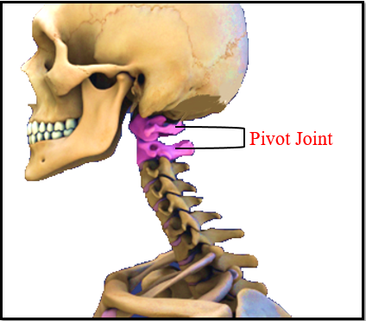
Neck joint is different from both the hinge joint and the ball and the socket joint. This joint helps us to move our head up-down and side to side.
But we cannot rotate our head totally. Neck joint is a type of joint called pivotal joint.
Ball and Socket Joint: It is found in shoulders and hip areas. This allows minimum movement and also contributes to maintaining a body structure.
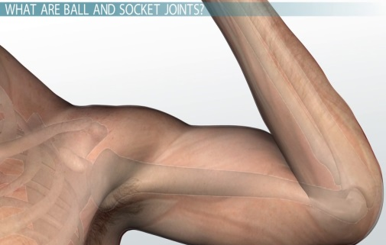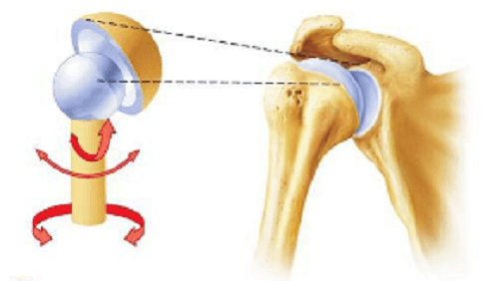
These joints have a rounded end so that one bone can fit into the hollow space of another bone. Such joints allow movement in all directions. For example, the joint between the upper arm and shoulder is an active example of ball and socket joint. Moreover, the joint falling between hip and thigh is also a suitable example.
Hinge Joint: Such joints are similar to the hinges present in a door. Hence, these joints permit movement only across a single plane. This joint is present in elbows, knees, etc. to provide the necessary movements.
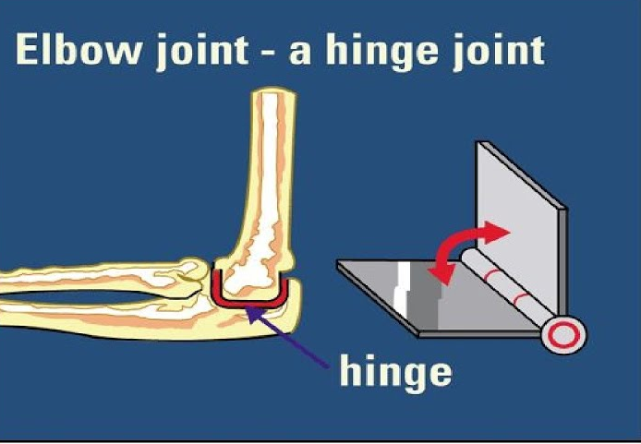
Therefore, you can see that joints play a vital role in shaping the human body as well as allowing different movements. Combining with muscles, they further facilitate easier movements as it contracts and relaxes.
The elbow joint and knee joint are good examples of a hinge joint.
Gliding Joint: Considering these joints, the movement happens as a result of sliding of bones on one another. In our body, the joints lying between the rings of the backbone can be seen as a perfect example of gliding joint.
