MOVEMENT IN ANIMALS
Movements in other animals:
We can move our body parts with the help of muscle bones and joints. Do all animals have these parts like us? Let us study how animals move.
Movement or locomotion is an important function in every living organism. It is very interesting to watch ants running hurriedly in a line, squirrels and monkeys jumping on trees. Try to enjoy watching various locomotions in the animal kingdom.
Locomotion in fish:
Fish swim in water. Do they swim the same way as humans? What is the difference? What features help fish in swimming and how?
It should be noted that the tail and head of a fish is usually smaller as compared to the middle portion. Such a body shape is termed as streamlined. Therefore, the shape allows the water to flow around easily and permit the fish to gain motion in the water.
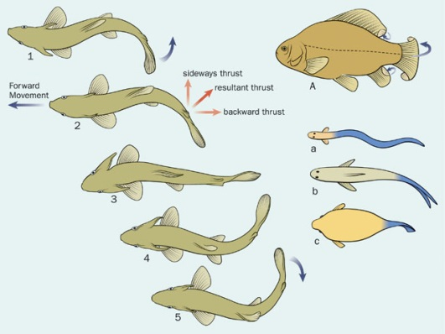

The body of the fish is streamlined. The shape is such that it allows the fish to move in water easily. The skeleton of the fish is covered with strong muscles. While swimming, muscles make the front part of the body swing towards one side while the tail swings its body towards the opposite side. This creates a jerk and pushes the body forward. A series of such jerks help the fish swim forward. The tail fins also aid in this movement.
Birds:
Birds fly in the air and walk on the ground. Birds can fly because their bodies are well suited for flying. Their bones are hollow and light. The bones of the hind limbs are typical for walking and perching. Bony parts of the fore limbs are modified to hold muscle of flight which is used to move the wings up and down.
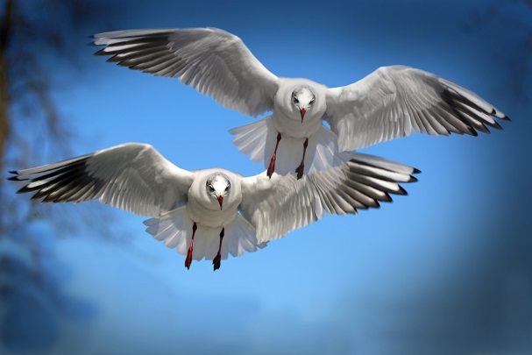
For a bird, the presence of light bones and strong muscles work together in order to develop movements that lead to flying action. A bird flies by flapping its wings.
Earthworm:
The body of an earthworm is made of many rings which are connected end to end. There aren’t any bones in the body. Moreover, the muscles are the prime reason that causes outspread and shortens actions.
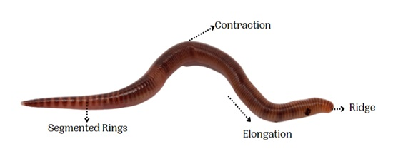
Moreover, the earthworm’s body discharges a slimy substance which helps in movement. Furthermore, it holds a large number of tiny bristles that project outwards. Each of these bristles is connected to the muscles for helping in managing a good grip on the ground.
Locomotion in snake:
Snakes have a long back bone and several muscles. Usually the snake's body curves into many loops. Each loop of the snake gives it a forward push by pressing against the ground. This helps the snake move forward very fast.
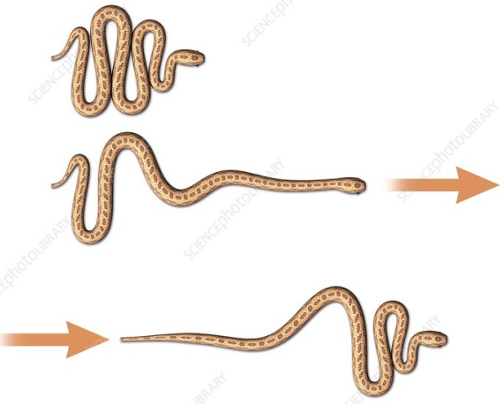
Locomotion in snail:
Snails carry a rounded structure over its back. The shell, as well as the outer skeleton of a snail, aren’t made of bones. It can be counted as a single unit and have no part in the overall movement of the body. Snails access movement with the help of a muscular foot.
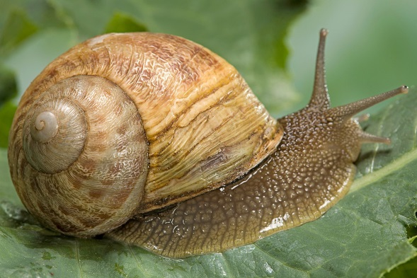
Collect a snail from a garden. Have you seen the rounded structure it carries on it back? Place the snail on a glass plate and watch it, when it starts moving. A thick structure may come out of an opening in the shell. The thick structure is its foot, made of strong muscle. The wavy motions of its foot is the reason why a snail moves slowly.
Don’t forget to put back the snail from where you collected it. If you let it go away it will die. You are a student with concern towards bio diversity.

