LIGHT, SHADOWS AND IMAGES
Light:
Light is a form of energy. We cannot see an object in the darkness. We need a source of light to make the object visible. During the day, Sun’s light allow us to see objects. At night artificial light make us see objects. Light enables us to see objects from which it comes or from which it reflected light. We detect light with our eyes.
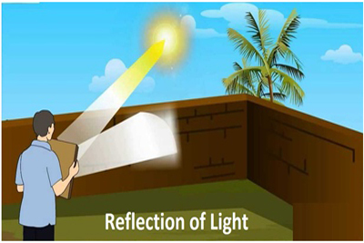
Sources of light:
An object which gives out light is called a source of light.
The various sources of light around us are Sun, stars, bulb, tube light, kerosene oil lamp, candle, torch, firefly etc.
The most important source of light for us is the Sun. It is about 150 million km away from us, its light makes the daytime bright on the earth. At night we use an electric bulb, tube light, lamp, candle or torch as a source of light.
Luminous and Non-luminous objects:
- An object which gives out its own light is called luminous object.
For example: Sun, stars, burning candles, electric bulb, glowing tube light, television screen, a piece of red hot iron, flame of gas burner, firefly are all luminous objects.
Since luminous objects give out their own light, they can be seen even in the dark. A luminous object can be seen because the light given out by it enters our eyes.
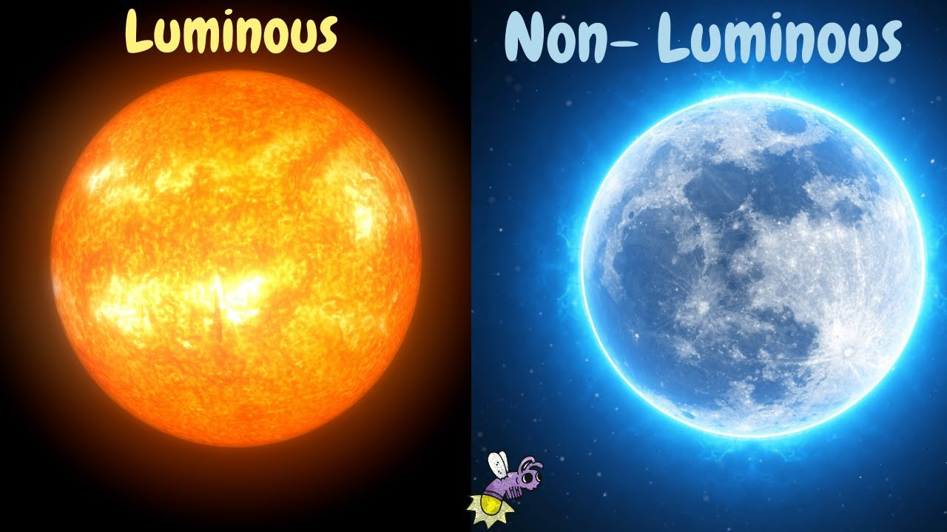
- An object which does not give out its own light is called a non-luminous object.
For example: table, chair, book, flower pot, plants, clothes, bags, pen, pencil, mirror, shoe, moon, earth, planets, etc.
The non-luminous objects can be seen only when the light coming from a luminous object falls on them. This light is reflected by non-luminous objects in all directions. When this reflected light enters our eyes, we can see the non-luminous objects.
For example: Moon is a non-luminous object which does not have its own light. We can see the moon because it reflects sunlight into our eyes. When sunlight falls on the surface of moon, then some of this sunlight is reflected by the moon towards the earth and to us it appears as if the light is being given out by the moon itself. But, moonlight is the sunlight which is reflected from the surface of moon. The planets can also be seen in the sky because they are reflectors of Sunlight.
The object is visible when there is no obstruction between your eyes and the object. If we keep obstructions like plank or writing pad, they do not allow something that is coming from the object to reach us. What is that something coming from the object? When we put on the bulb, light falls on the object, bounces from the object and reaches us. We can see an object only when light falls on it and bounces back to our eyes.
We can see many things kept in a room during the day on which sunlight does not fall directly. All the objects outside the room scatter the sunlight falling on them in all the direction. Even the air scatters some sunlight. It is this scattered sunlight which enters the room and helps us to see the things lying in the room which are not in direct sunlight.
We can see the table because it reflects the light falling on it in all directions and when this reflected light coming from the table enters our eyes, we are able to see the table.
Transparent, translucent and opaque materials:
Depending on behavior towards light, all the materials can be classified as transparent, translucent or opaque objects.
Transparent materials or objects:
- The materials which allow all the light to pass through them are called transparent material.
For example: glass, polythene, air, water and oil
If we look at a burning candle through a sheet of clear glass, we can see the candle and its flame clearly. This is because glass is a transparent material which allows all the light coming from candle and its flame to pass through it.
- The window panes in our homes are usually made of transparent glass.
- Our spectacles glasses are also transparent.
- The glass tumbler in our kitchen are also transparent objects.
- The test tube, flasks and beakers in Science laboratory are transparent.
- A car windscreen is transparent.
If we are able to see through an object clearly, it is allowing all the light to pass through it and hence it is a transparent object.
Translucent Material:
- The material which allow only some of the light to pass through them are called translucent materials.
For example: ground-glass, butter paper, oil paper, tissue paper, sheet of white cotton, muddy water, clouds etc.
If we look at burning candle through a piece of ground glass or butter paper, we can see only a dim light of the candle. We can neither see the candle itself nor the candle flame clearly through the ground glass.
- The windows of bathrooms in our homes are made of translucent material called ground glass so that though some outside light may enter the bathroom but nothing is visible clearly from outside.
- Clouds are translucent. Though, we cannot see the sun through clouds on the cloudy day but still there is some sunlight all around. This is because being translucent, clouds allow some of the sunlight to pass through them due to which there is a light on earth even on cloudy day.
The translucent objects absorbs or reflect a good part of light falling on them and allow only some of the light to pass through them.
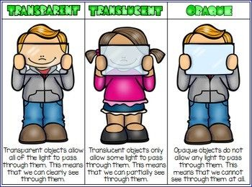
Opaque Objects:
- The materials which do not allow any light to pass through them are called opaque materials.
For example: cardboard, book, door, metal sheet, brick wall, stones etc.
If we look at the burning candle through a piece of cardboard held in front of our eyes, we cannot see anything at all. This is because the cardboard does not allow the light of candle flame to pass through it and reach our eyes.
- We cannot see anything through a wooden door because the wooden door is an opaque object which does not allow any light to pass through it.
The Opaque objects do not allow light to pass through them because they absorb or reflect all the light falling on them.

