LIGHT, SHADOW AND IMAGES
Shadows:
When an object is placed in front of a source of light, it produces a shade or dark area behind it. Shadows are formed when light is stopped by an object.
What sort of objects stops the light?
- An opaque object stops the light completely, so an opaque object casts a dark shadow behind it.
- A translucent object stops the light partially, so a translucent object casts a weak shadow.
- A transparent object does not stop any light from passing through it so a transparent object does not cause any shadow behind it.
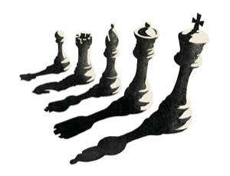
A shadow is formed when an opaque object comes in the path of light and stops it. An object forms shadow on the opposite side to the source of light. The shadows of objects are usually similar in outline to the object and hence we can identify the object from their shadows.
The shadow of a ceiling fan hung in the centre of room will fall on the side opposite to the lighted electric bulb. A lighted candle fixed in a room will also cast our shadow and that of the ceiling fan on the opposite side.
The sunlight also forms shadows of the objects which are on the ground or near the ground. If we stand in the sun, our body cast a shadow on the ground and when we walk in the sun, our shadows always walk with us.
Our shadow is very long in the morning when the sun just rises. The length of our shadow goes on decreasing by noon. Our shadow is shortest at noon. The length of our Shadow starts increasing in the afternoon and becomes very long in the evening, just before sunset.
The shadow of an object can be seen only on a screen. The surface such as the walls of a room, a building and even ground act as screen for the shadows which we see in our everyday life.
We require three things to observe a shadow.
(1) A source of light,
(2) An opaque object and
(3) A screen on which the shadow can be seen.
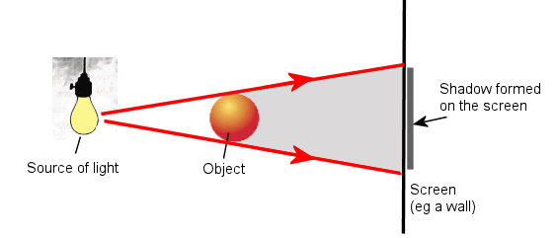
Shadows are formed because light rays travel in a straight line, and they cannot bend round the corners of the objects. The shape of the shadow is also the same as the shape of the object because light travels in a straight line path.
- When a bird is on the ground, we can see its shadow which is formed by sunlight. The bird obstructs the sunlight to form shadow on the nearby ground. When the same bird is flying high up in the air, even the bird obstructs the sunlight falling on it but its shadow is not seen on the ground because the ground is very far below the bird.
- When an aeroplane is parked on the ground, we can see its shadow which is formed by sunlight. The aeroplane obstructs the sunlight to form a shadow on the nearby ground. When the same aeroplane is flying high up in the air, even the aeroplane obstructs the sunlight falling on it its shadow is not seen on the ground because the ground is very far below the aeroplane.
Sometimes the shadow of opaque objects are not seen clearly. Our shadow and that of a ceiling fan formed by an electric bulb or a lighted candle can be seen clearly but the shadow formed by a fluorescent tube light cannot be seen clearly.
An electric bulb and candle forms shadows because they are comparatively small sources of light.
A fluorescent tube light does not form sharp shadows because it is quite large source of light. Since a fluorescent tube light is very long, some of the light from it always reaches behind the opaque objects leading to the formation of a very faint shadows. The shadows formed by fluorescent tube light are so faint that it is usually very difficult to see them.
Characteristics of shadow of an object:
(1) The shadow of an object is erect i.e. same side up as the object.
(2) The shadow of an object is real.
(3) Irrespective of the color of the object, the shadow is always black.
(4) The shadow can be smaller than object, equal or bigger than object.
No Shadow can be formed when there is no source of light as on a dark moonless night or in a dark room.

