LIGHT, SHADOW AND IMAGES
Light travels in straight line:
If we Shine a torch on a dark night we will see that the beam of light produced by a torch travels straight into darkness.
The beams of search light at the airport show that light travels in straight lines. The beam of light coming from the projection room of a cinema hall and falling on the screen also shows that light travels in a straight line.
Making a pinhole camera:
- A pvc pipe, about 8 cm in diameter and of length 30 cm.
- A pvc pipe, about 7 cm in diameter and of length 20 cm.
- One black drawing sheet.
- oil - 1 ml, two rubber bands, a pin, and A4 sheet.
(If you cannot get pvc pipes, take a thick sheet of paper and roll it to form tubes. The diameter and length of the tubes should be the same as that given for the pipes).
Cut a piece of black paper and put it like a cap at one end of the big pvc pipe and fix it with a rubber band. Put the white paper like a cap at one end of the thinner pvc pipe. Fix it with a rubber band. Now make a hole in the middle of black paper cap with the help of a pin. Put 2 to 3 drops of oil on the white paper cap so that it becomes translucent. Insert the thin pipe into the big pipe. Your pinhole camera is ready. Arrange a lighted candle in front of the pinhole of the camera. Move the thinner pipe forward and backward to get a clear picture of the candle on the screen of the thin pipe.
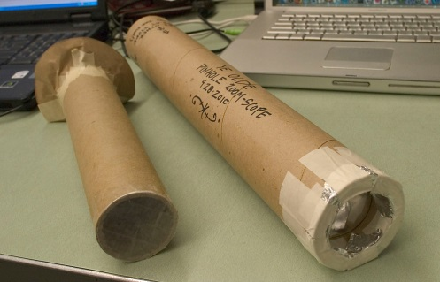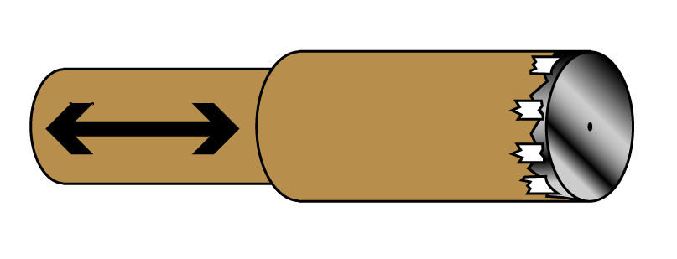
This picture is to be observed from the back of the thin pipe. What do you see? The flame of the candle appears inverted on the screen. Why is it like that? This is not the shadow of the candle. It is its image. Try to understand how light enters into the pinhole camera. This will explain the reason for inversion of image.
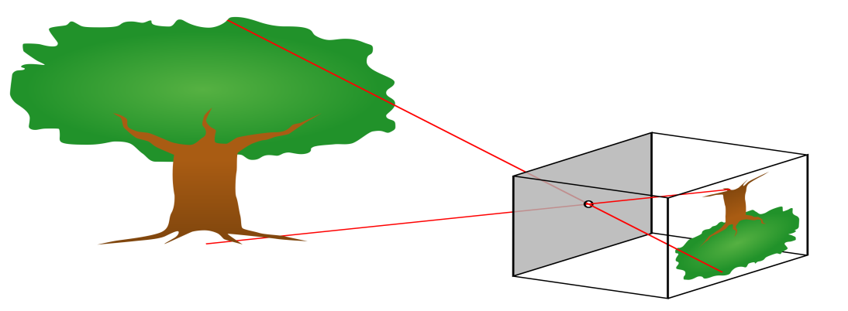
The light from the candle travels straight in all directions from each point of the flame of the candle but only the light coming in some particular directions can enter into the camera through its pinhole. Light which comes from the point at the top of the flame goes straight towards the bottom of the screen and light which comes from the point at the bottom of the flame goes straight towards the top of the screen, as shown in picture. In this way, the light coming in a particular direction from each point of the flame, will be able to enter into the pinhole and light going in other directions is blocked by the black sheet.
This leads to the formation of an inverted image. The formation of inverted image on the screen of the pinhole camera explains that light travels in a straight line.
What do you see?
We get the full image of the tree in the pinhole camera but when we put a candle in front of the pinhole camera, we get the image of the flame only.
Why is it so?
Activity: Image with a magnifying lens
Take a magnifying lens and try to form an image of a tree on a white drawing sheet.
What do you observe in the image formed on the sheet?
The image on the white drawing sheet is inverted. Isn't it? What difference do you notice between the images formed through the pinhole camera and through the magnifying glass? You may notice that the image formed through the magnifying lens is clearer than that formed with a pinhole camera.
Differences between Image and Shadow:
We see our face in the mirror every day. Is this picture in mirror a shadow or an image? How did you decide that? We know that shadows are not colored but an image has colors that are same as that of the object. Also, a shadow shows only the outline of the object but an image shows the complete object as it is, just like a photograph.
Can you find any other differences or similarities between shadows and images?
(1) The pinhole image of an object is inverted whereas the shadow of an object is erect.
(2) The pinhole image of an object is of the same color as the object but the shadow of an object is always black.
The formation of image in a pinhole camera and the formation of shadow by object placed in the path of light provide the evidence that light travels in a straight line.
Activity: Observe the Reflection:
Make your classroom dark by closing doors and windows. Ask one of your friends to hold a mirror in his hand. Take a torch and cover its glass with a black paper leaving only slit in the middle. Now switch on the torch and adjust it so that light falls on the mirror in your friend’s hand. Ask your friend to adjust the mirror so that the patch of light falls on another friend standing in front of him at some distance.
When light falls on any object, it rebounds back. This is called reflection.
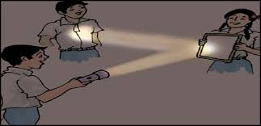
Ask your friend to cover the mirror with a book. Now switch on the torch and focus it on the book. Can you see the patch of light on your friend? Why? Did the light that fell on the book not get reflected? We know that we can see the objects only after light is reflected from them.
If light falls on any object, it is reflected back but we see reflected light, as if from a source, only when it falls on the objects like mirror. You can reflect sunlight using mirrors and play with it. Make sure that the reflected light does not enter your eyes.

