LIVING AND NON-LIVING
EXERCISES:
- List out common characteristics of living things.
Ans: Cellular organization, the ability to reproduce, growth & development, energy use, homeostasis, response to their environment and the ability to adapt are the characteristics of living things.
- Why do cockroaches come out of their places when lights are put out?
Ans: Cockroaches are nocturnal animals who come out in the night in search of food. In day time, they hide in dark and damp places. By evolution, cockroaches have become nocturnal creatures or those which have their major activities in night. Nature has given the cockroaches power to see in the dark. They have the ability to see objects around as they are provided with numerous eye lenses unlike humans and other higher living thing that have only one lens in an eye.

- Which characteristics are same in both living and non-living things?
Ans: The same characteristics in both living and non-living things are both have mass, shape, occupy space and they are made up of basic structural units that are cells and molecules.
- Which of the following are derived from living things: sugar, coconut oil, pen, rice, fan, omelet, bus, wooden chair, garland, mango, clothes, fruit juice.
Ans: Sugar, coconut oil, rice, omelet, wooden chair, garland, mango, clothes and fruit juice are derived from living things.
- How can you say that a tree is living even though it doesn't move?
- Ans: Trees have a cellular organization like other living things.
- Trees prepare food through photosynthesis.
- Trees can reproduce by producing seeds through sexual methods.
- Trees need water, air, sunlight to grow and get energy.

- What is the use of microscope?
Ans: A microscope is an instrument that can be used to observe small objects, even cells. The image of an object is magnified through at least one lens in the microscope. This lens bends light toward the eye and makes an object appear larger than it actually is.
- Thread like structure developed in bread are ---------------
Ans: mould
- Which of the following is not a response to stimulus :
a) Feeling cold by touching ice.
b) Feeling the weight of carrying a bag of books.
c) Scratching the skin at the place of ant bite.
d) Closing eyes immediately after seeing bright light.
Ans: Any process that results in a change in state or activity of a cell or an organism as a result of a stimulus is called as response.
b) Feeling the weight of carrying a bag of books cannot be considered as a response to stimulus.

- Collect sweet potato, bottle, salt, and water. Take a bottle full of water and add salt, then put the sweet potato inside the bottle. Observe for few days. What happens? Note your observations. How can you prove that sweet potato is also a living thing?
Ans: When we add salt to the water, water becomes concentrated with salt. When we put sweet potato, the solution becomes hypertonic to the cells of sweet potato. As the sweet potato cells are hypotonic to a salt solution, water from the sweet potato cell will be drawn to the salt solution through osmosis and this continues until the salt solution is isotonic to the sweet potato cells.
As the water is drawn from the sweet potato cell, the cells will become plasmolyzed and the sweet potato becomes flaccid. This proves that sweet potato is a living thing.
- Venkatesh argues with his friend Tanveer about “seed is living” Think. What questions does Tanveer ask?
Ans: The possible questions could be:
- Where does the seed get food from?
- Will it die if stored for a long time?
- What happens when a seed is sown in soil?
- How come there is no growth and movement observed in seeds immediately like other living things?
- If seeds are living things, do they respond to the stimulus?
- What will happen if there is no stomata in leaves? Write your predictions.
- Ans: Lack of stomata stops consumption of carbon dioxide by leaves. As a result, photosynthesis stops.
- Absence of stomata in the leaves affects decrease in percentage of oxygen in the atmosphere, which is to be released by plants. No gaseous exchange take place in plants.
- As a result, all the animals suffer a lot due to lack of oxygen. Finally, the animals die.
- Hence, to regulate carbon dioxide and oxygen, stomata are essential in the leaves.
- Transpiration is another important property that is done through stomata to eliminate excess water from plants.
- Write down the steps of the experiment that you did in the lab to observe micro-organisms in pond water.
Ans: Pond water is collected from the village pond. A drop of pond water is placed on the glass slide. Cover the glass slide with cover glass. Now, the glass slide is kept under the microscope. The lens of the microscope is adjusted.
Observation: While observing the water drop under microscope, different microorganisms are observed.
- How do you feel when you touch ‘Touch me not’ plant? Write your feelings.
- Ans: When I touched a “touch me not’ plant, the leaves get folded all of a sudden.
- Touching them with my hand is stimulus and folding of leaves is response.
- It is a wonder that how leaves behaved in such a rare manner.
- I felt that not only animals, but also plants respond amazingly to the nature’s stimulus.
- Prepare Venn diagram to represent living and non-living characteristics of dog and tree.
Ans:
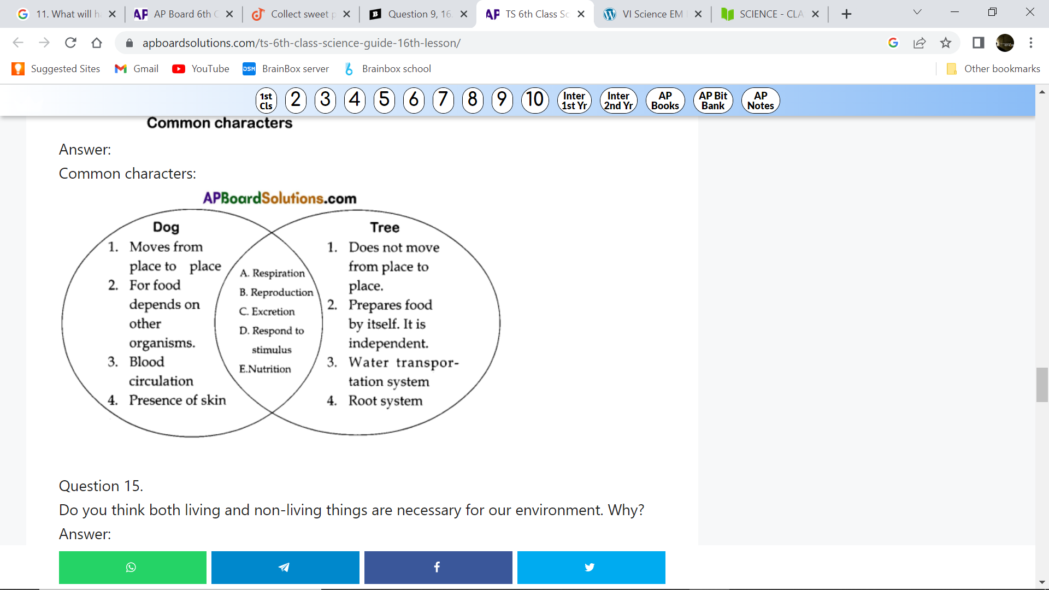
- Do you think both living and non-living things are necessary for our environment. Why?
Ans: Living and non-living things are necessary for our environment. Because, all the living things should depend on non – living things like air, water and soil for various life activities. For example, animals take oxygen from air for breathing. Likewise, plants consume carbon dioxide from air. Air is a component of non – living things. Not only air, living things need water, food, air, space or shelter, and light for living.
When living things lose their life, they become non-living things. Dead material decomposes to form non-living things.
We should take care of protecting the nature by utilizing the non-living things in a judiciary way.
- Collect information from your school library / internet about Sir J.C. Bose who invented response to stimulus in plants.
- Ans: Jagadeesh Chandra Bose, an eminent scientist from India, contributed valuable information to the world of living things.
- He conducted several experiments on plants and discovered that plants have life. He also said that they exhibit feelings.
- He discovered an instrument ‘CRESCOGRAPH” to find out the growth of plants.

