LIVING AND NON-LIVING
LIVING – what does it mean?
The simple answer we all know is things which are alive and breathing. Right!
A bird moves and makes noise and so does a car; both must be living things. Is it so?
Anything that has a fixed life cycle is considered to be a living thing. A seed doesn’t do anything (seemingly), but a young plant changes and grows. So, a seed must be non-living. But in reality they are dormant which means under proper conditions they germinate and develop into younger plants.
Any organism that eats, grows, reproduces and then eventually dies is called a living thing. Natural living things cannot live forever and must eventually perish.
A leaf that has fallen off a tree is dead, which also means not alive. Does that mean dead leaves are non-living things?
Here we must understand the difference between “once living” and “never living”.
It is important to understand that Living Things:
1. Need water, food, air, space or shelter, and light (for most plants).
2. Grow, develop, change, and die.
3. Are able to reproduce.
Living creatures’ life cycle is as follows:
Born →Live and Grow →Reproduce →Die
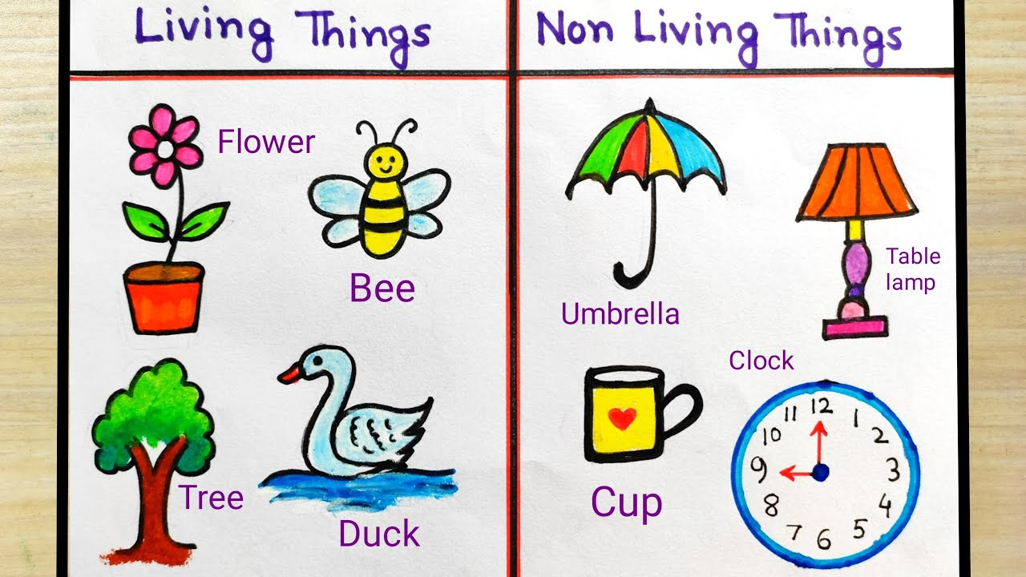
Characteristics of Living Organisms
Some of the important and common characteristics are:
- Movement:
They are capable of showing locomotory motion. For example, humans and animals move by walking and worms move by crawling through the soil. All of them are given the privilege of moving from one place to another except for trees and plants.
- Organization:
Living things are made up of ‘cells’, which are called the building blocks of life. These ‘cells’ are properly and systematically organized in a living organism. All living beings are made up of one or more cells.

- Reproduction:
A living thing must be able to reproduce. They should be able to create offspring. This can be through both sexual and asexual reproduction. An organism passes on its genetic information to its offspring through reproduction.
Sexual reproduction involves two parents, a father and a mother, to produce new offspring. On the other hand, asexual reproduction involves only one parent. Few plants do this type of reproduction.
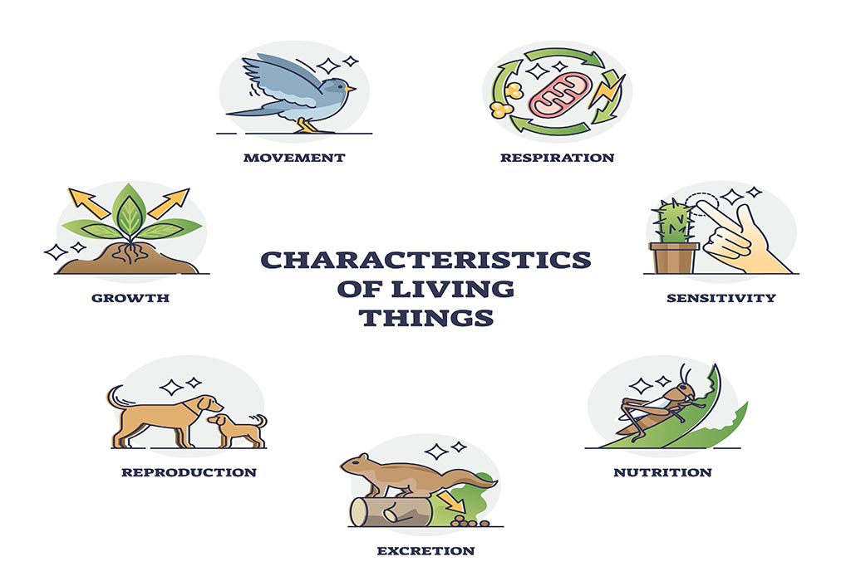
- Growth
All living things grow. We are born a different size and we die a different size. Other living things, such as plants and fish, grow too! Living things grow every second, but we cannot see their results, as the growth is very minute. As lengthier as we get, our maturity increases and that helps us make better decisions in our lives.
- Require Nutrition
All living organisms require nutrition in some form or another. They require nutrition for growth and survival. For us humans, this means eating food and drinking water and for plants, this entails making their own food by photosynthesis.
- Respiration:
To release the energy acquired from food and water, the respiration process takes place. We breathe to survive and living would not be possible without respiration. In respiration, there are two forms. One is inhalation; it means inhaling the air into our lungs through respiratory tubes. Meanwhile, the other one is exhalation; it indicates exhaling the already inhaled air through respiratory tubes to the surrounding.
- Touch-sensitive:
They are touch-sensitive. They can feel things as long as they do not go numb. For instance, if you touch dogs on their heads, they would feel that touch and get attached easily because they love to be petted. It goes the same for other organisms, and almost all are sensitive to touch.
- Adjustability:
All living things interact and adjust to their environment. We have warm-blooded and cold-blooded organisms; both have unique ways of adjusting their body temperatures according to their environment. Living beings also respond to stimuli in their environment.
- Adaptability:
All living things must adapt to their environment to have a better chance of survival. One good example of this is how giraffes have really long necks so that they can reach the top of trees where the fresh leaves are situated. Even plants adapt to their environment. One such example is cacti. They are usually found in deserts where water is scarce. Hence, they have developed roots which grow long and deep to be able to find water.
- Excrete Waste:
All living animals excrete waste. As we know, energy can’t be destroyed and is merely passed on from one form to another; excretion is also a form of release of energy from a living organism’s body.

When living things lose their life, they become dead. Dead is an intermediate stage between living and non-living things.

