LIVING AND NON-LIVING
What are non-living things?
The meaning of non-living things is simply the things around us that are not living. Such objects do not possess life and don’t have a lifespan or need food and energy as living things do. They do not have the same features as living things. Non-living things merely just exist and share space in the world we call our home.
The immortality of the non-living things purely depends on the type of the thing. Some things, such as mountains and rivers, have existed for thousands of years.
In addition, they do not require energy to survive. They have a whole different purpose. Some serve their life as living things.
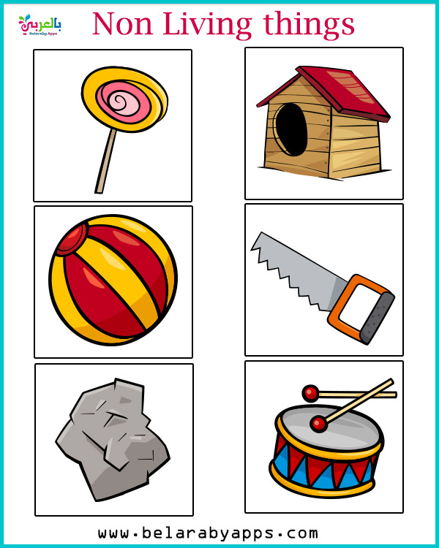

What are the characteristics of non-living things?
Non-living things, too, have their own characteristics, which help us identify them. Some basic characteristics of non-living things are:
- Non-living things are lifeless objects that do not possess life. They are not made up of living cells and do not perform any metabolic activities.
- They cannot travel from one place to another without the help of an external force. Hence, they do not show locomotion.
- They don’t require nutrition. They simply exist without the need for any form of life-supporting processes such as respiration or metabolism.
- They do not reproduce offspring, and there is no process of reproduction involved in their life cycle.
- They do not die. They need to be destroyed using external force or must be consumed for the production of other items.
Interestingly enough, non-living things can be categorized into two types:
Natural non-living things:
Natural non-living things have been existing by themselves since the start of the universe. They can be anything from stars and planets to mountains, rivers and other natural resources. Living things consume natural resources daily, such as water, fire, coal, and fuel. Most of these resources are infinite. Therefore, these resources play a vital part in everyone’s life.
The examples are mountains and hills, rivers, seas and oceans,
stones and rocks, coal, planets and stars etc.
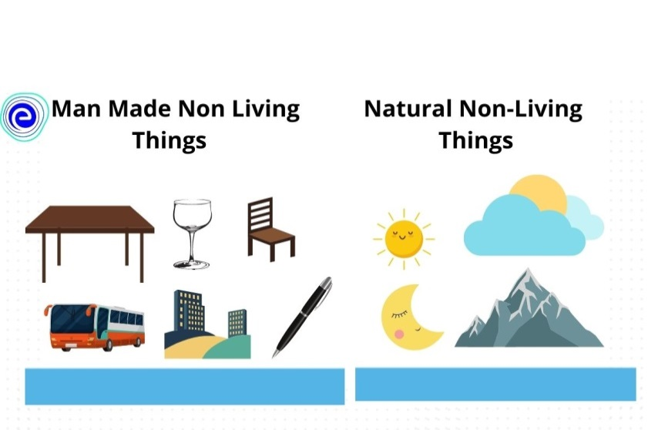
Artificial (or manmade) things:
Humans or other creatures create these types of non-living things. The objectives of such kinds of things are to serve mankind. For instance, we can use smartphones to do various tasks such as calling, texting, surfing the internet, etc. These things have a limited lifespan but vary from one thing to another. Although short-lived, they are very helpful in serving our daily needs.
Blender, refrigerator, oven, chairs, benches, doors, sofa, table, cot, clothes, dresses, blankets, towels, books, pencils, pens, papers and other stationery items etc. are all examples of non- living things.
One great thing about non-living things is that they never die, as they never live. However, they have their lifespan. For example, a smartphone will stop working after 3 or 4 years of usage; a table might break after ten years, etc.
Essential things in life, namely breathing, reproduction, respiration and movement are all absent in non-living things.

