LIVING AND NON-LIVING
LIVING THINGS UNDER A MICROSCOPE:
Microorganisms (also called microbes) are living organisms that can be only seen through a microscope. Microorganisms are present everywhere, and they can survive in all types of environments. They are also present in the bodies of different animals and plants. Some microorganisms are useful for plants, animals, and humans, whereas others cause diseases. Viruses are sometimes classified as microorganisms, but viruses are just genetic materials that can live only in the bodies of other organisms. Examples of microorganisms include amoeba, bacteria, etc.
Microorganisms are found everywhere, in every corner you can imagine. They are found on your palms, books, pen, table, food, mobile phones, soil, hair, and even in your intestines. There may not be any possible place where microbes do not exist.
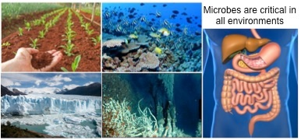
They adapt to the environment in which they live. They can survive in extreme conditions like ice-cold areas, hot springs, equators, deserts, polar regions, oceans, and marshy lands. They are also found inside other living organisms like plants, animals and humans. Millions of microbes are found in the human body. Some microbes cause diseases, whereas others are useful for us. Some microorganisms live freely, whereas others grow on other living organisms.
The tiny thread like structures generally observed on bread are commonly called mould. Can we say that mould is also living? The mould that develops on spoiled material is able to produce new mould. It grows. So we can say the mould is also living.
Curd contains several microorganisms. Of these, the bacterium, Lactobacillus promotes the formation of curd. It multiplies in milk and converts it into curd. Bacteria are also involved in the making of cheese, pickles and many other food items.
Microorganisms as Friend:
- Microbes present in milk (Lactobacillus) help in the conversion of milk to curd.
- Microbes present in the intestines of humans and animals help in digestion.
- Microbes (yeast) help in making bread and cakes.
- Microbes present in batter help in the souring of dosa batter.
- Microbes are useful in the large-scale production of vinegar, alcohol, and wine through fermentation.
- Microbes are used in the production of antibiotics such as Streptomycin, tetracycline, erythromycin, etc.
Harmful Impacts of Microorganisms:
Microorganisms that cause diseases are called Pathogens.
Some microbes cause communicable diseases which spread from an infected person to a healthy person through food, water, and air.
Example: chicken pox, common cold, cholera, etc.
Some microbes spoil food and cause food poisoning.
A microscope is a very powerful magnifying glass. The entire world — our bodies included — are made up of billions of tiny living things that are so small you can't see them with just your eyes. But with a microscope, it's possible to examine the cells of your body or a drop of blood.
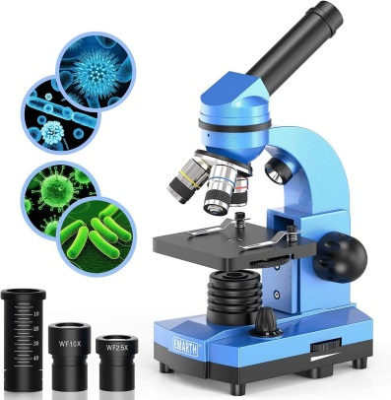
Microscope is an instrument with the help of which we are able to see minute things that we cannot see with our naked eyes. It works like a hand or magnifying lens but it is much more powerful. Basically, there are two components in a microscope - the structural component and the visual components. Structural components are the head/ body, base and arm. Visual components are eyepiece, objective, nosepiece, coarse and fine adjustment knobs, stage, aperture etc.
Microorganisms are too minute in size to be seen by unaided eyes, hence are observed and studied using microscopes. The image of an object is magnified through at least one lens in the microscope. This lens bends light toward the eye and makes an object appear larger than it actually is.
Compound microscopes are commonly used in research labs and institutes to study microorganisms. They use glass lenses to bend and focus light rays and produce enlarged images of small objects.
A stain is a chemical that adheres to structures of the microorganism and in effect dyes the microorganism so the microorganism can be easily seen under a microscope.

